2016 Nativity at St. Mary’s Church, Beaumont

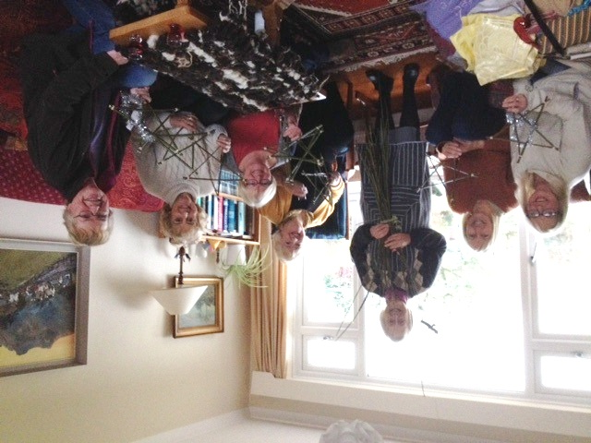
Preparation for the Nativity

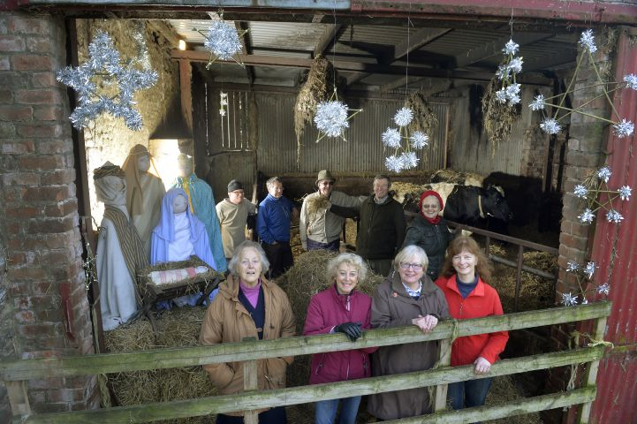
. Parishioners pose for the Cumberland News
Back: Albinas, David, Harold, Jim, Kathleen
Front: Margaret, Eve, Ann, Bryony

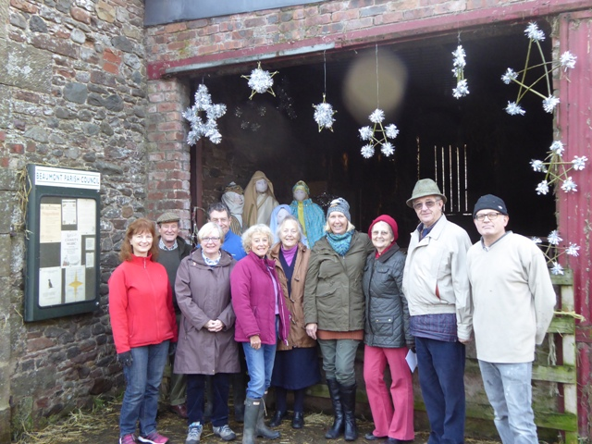
Bryony, Jim,Ann, David, Eve, Margaret, Carol, Kathleen, Harold, Albinas

