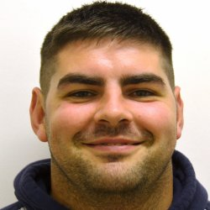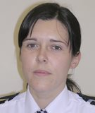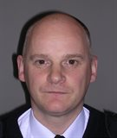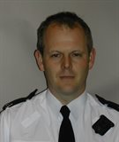

PCSO 5350

KATHRYN GRAHAM

PCSO 5324

STUART GRAHAM

***CONTACT US:-***

TELEPHONE : 101

IN AN EMERGENCY DIAL: 999

EMAIL: 101@CUMBRIA.POLICE.UK

***FOLLOW US ON:-***

@CUMBRIAPOLICE

**AREA PRIORITIES**

Work is on-going in relation to speeding in areas of Dalston, Cummersdale and Great Orton.

There will be a TDU (Speed Monitoring Device) being placed outside the school at Great Orton sometime in the near future this will record vehicle speed through the village and will give us an indication as to whether there is an issue or not.

I understand that there has been several complaints regarding a certain Campervan parked within the Square at Dalston, unfortunately neither Police or Local authorities such as the council can deal with this perceived issue as it is not causing any obstructions it has all necessary documents for it to be road legal and there are no parking restrictions within the Square.

**EVENTS**

Visit us at The Police Desk at the CO-OP Dalston on 17th February and 2nd March between 6pm - 8pm, we will be there every second Wednesday.

**CRIME**

There will be a new PCSO covering the Dalston Area from March as Myself and David are due to leave for pastures new by becoming Police Constables for Cumbria Constabulary.

***‘I am looking forward to being a part of the Dalston Team, and wish my colleagues Stuart and David ‘Good Luck’ in their new roles as Police Constables’.***

***-Kathryn Graham 5350***

**\*\* POLICE URGE THE PUBLIC TO KEEP ALL DOORS AND WINDOWS LOCKED. IF YOU HAVE ANY INFORMATION RELATING TO A CRIME IN YOUR AREA CONTACT POLICE OR CALL CRIMESTOPPERS ANONYMOUSLY ON 0800 555 111. \*\***

**DALSTON, BURGH BY SANDS & CUMMERSDALE**

**CARLISE CITY WEST GAR NEWSLETTER 10th FEBRUARY 2016**

**YOUR COMMUNITY TEAM**

INSPECTOR 602

NEIL THOMSON

SERGEANT 603

CHRIS BLAIN

PC 1992

LORI TALLANTIRE

**AREA PRIORITIES & EVENTS**

**CRIME IN YOUR AREA**