William and Olive Story

James Telford was appointed as sub-postmaster in Kirkandrews in 1900
Olive Story was born in 1901.

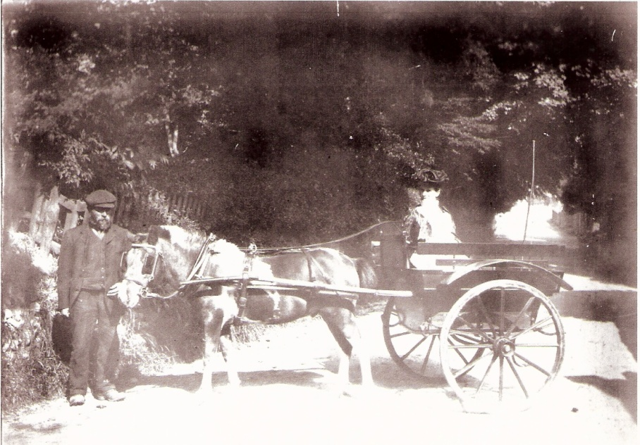
Olive lived with her family, James and Mary Ann Telford in Kirkandrews House. Mary Ann Telford was the Postmistress in a cottage besides Kirkandrews House where they lived. The family moved to the Old Post Office in 1906. Olive, aged 18, became full time assistant to her grandfather in 1919.

Olive on her grandmother’s knee at Station Bridge, Kirkandrews-on-Eden in 1902.

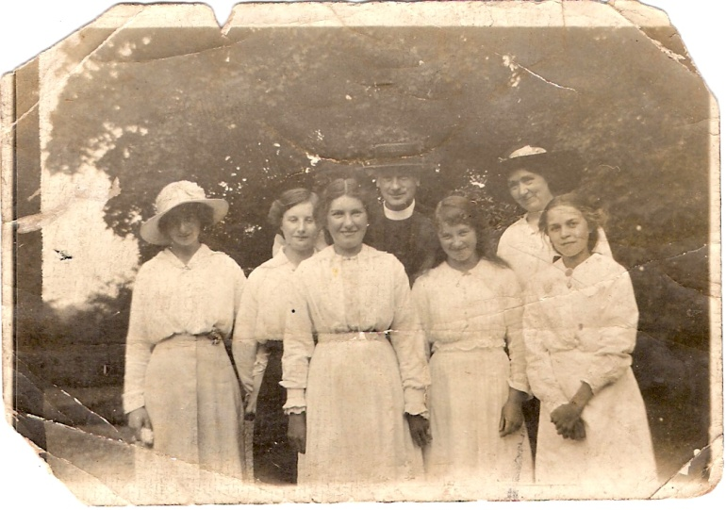
Olive Telford aged 16 next to the Post Office.

In 1924 Olive married William Story. James Telford died in 1932 and The Old Post Office, which had been inherited by his daughter Catherine Bell, was gifted by Catherine to William and Olive Story. William Story married Olive Telford in 1924 and they had the following children: Annie, Robert, Mary, and Alice.
William was a keen local historian. His wrote a short history of Kirkandrews on Eden.

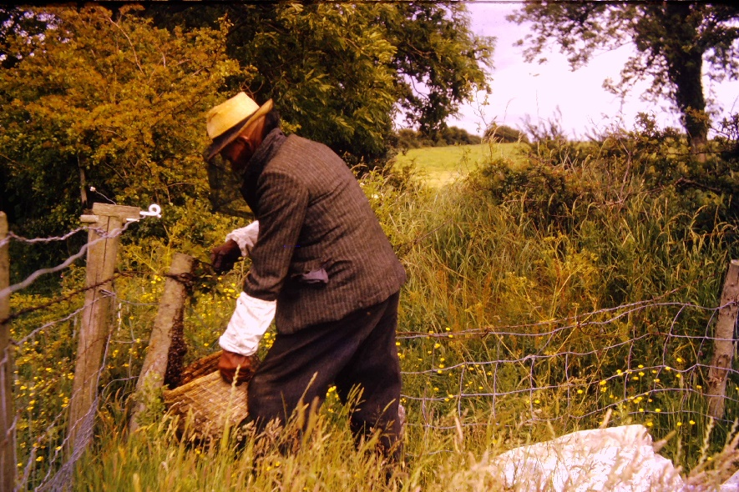
Collecting a bee swam in 1963

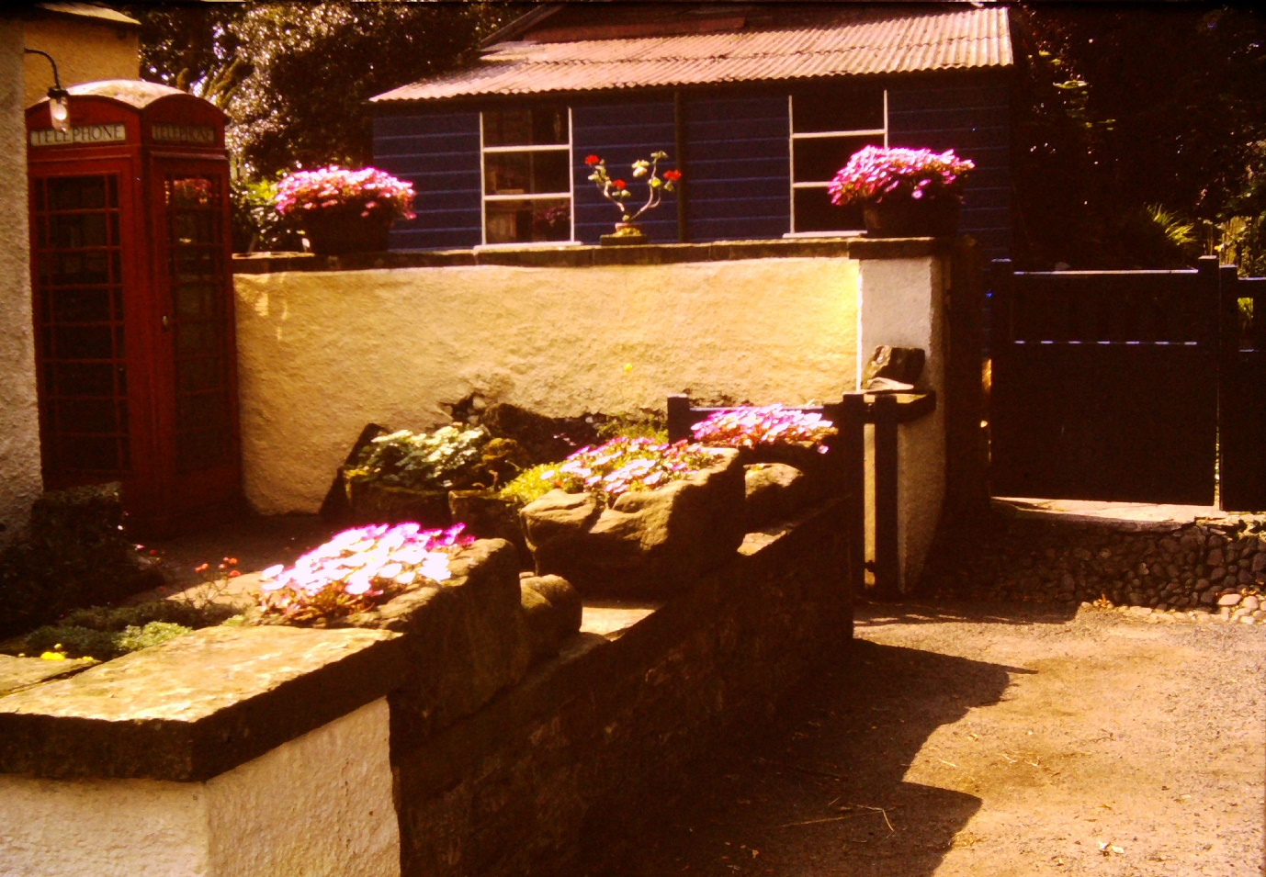
Photograph of the front of the post office in 1965.

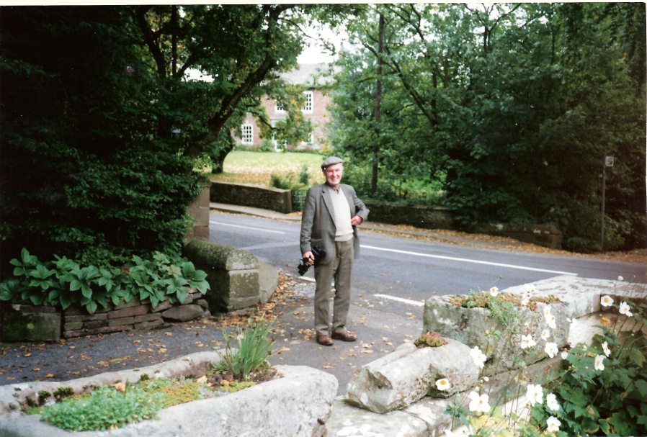
Jasper Mitchell outside the Old Post Office in Kirkandrews-on-Eden

In 1984 William and Olive celebrated their 60th wedding anniversary. Olive who was 83 at the time had by then served as Postmistress in Kirkandrews for 55 years. The couple received a telemessage from the queen, a letter from MP Ron Lewis and congratulations and a bouquet of flowers from all the post office staff in Carlisle, the flowers were presented by assistant head postmaster of Carlisle Gordon MacDonald.

William Story died in 1986.

Olive worked in the Post Office of Kirkandrews for75 years. She retired in 1994 at the age of 93 and at the time was Britain’s oldest Sub-Postmistress.

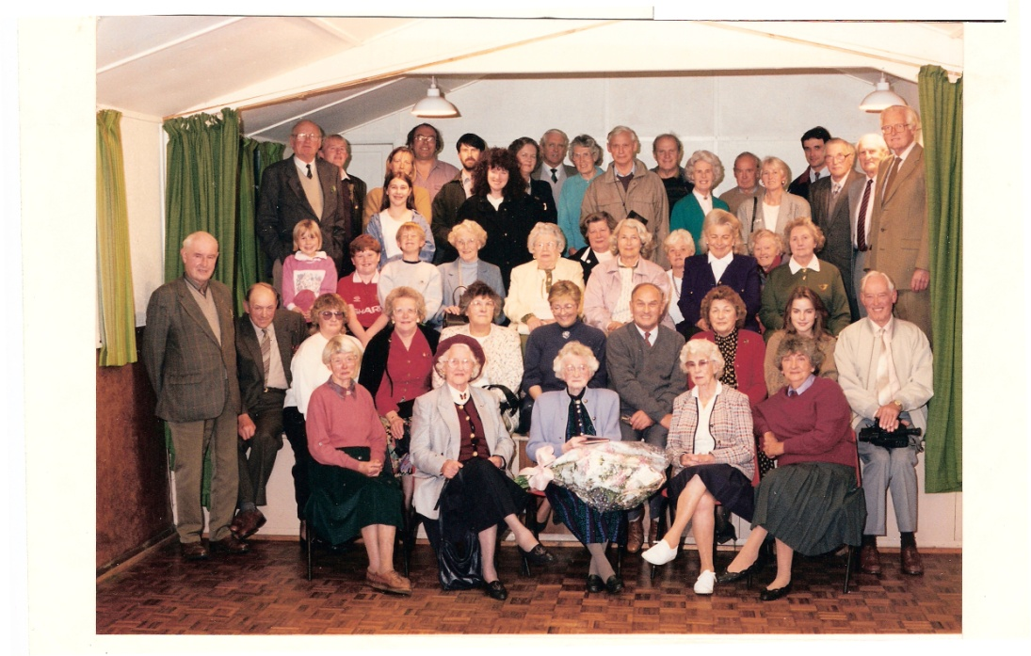

The Post Office closed following Olive’s retirement.

Photograph of Olive’s retirement in 1994.

Olive Story died in 2001.

