WI Centenary – Planting a centenary Oak at Beaumont Parish Hall

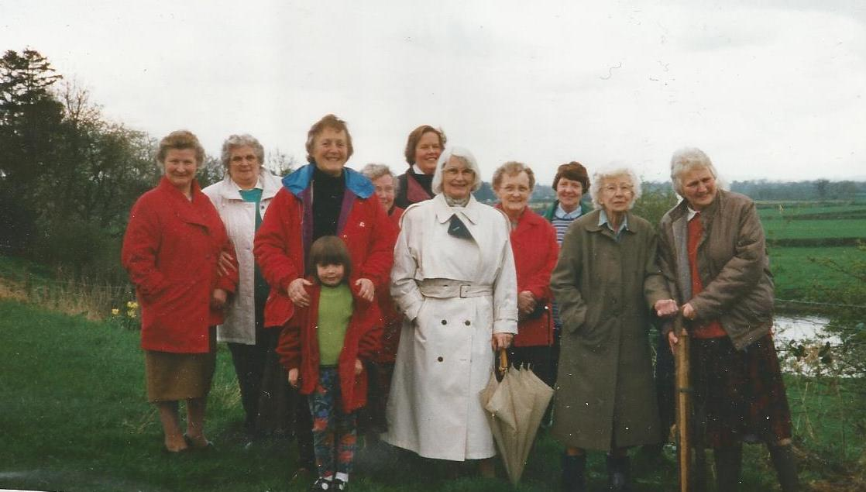
Left to right: Margaret Sewell, Margaret Roe, Margaret Parkinson, Cathy Stephenson, Sigrid Little, Thelma Burgess, Sadie Bell, Margaret Vickers, Stella Hodgson (WI President)

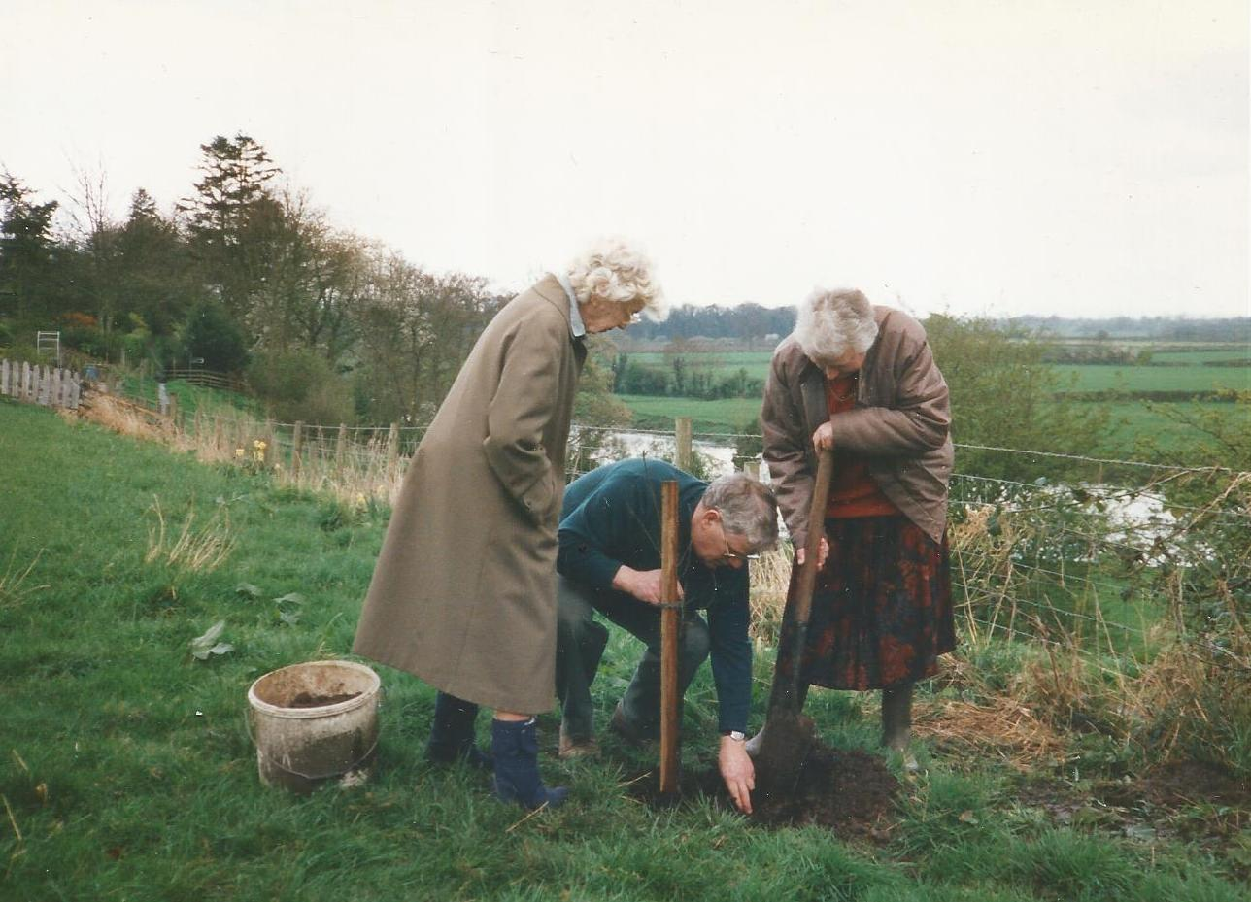
Miss Margaret Vickers oversees the planting of the oak by Alan and Stella Hodgson
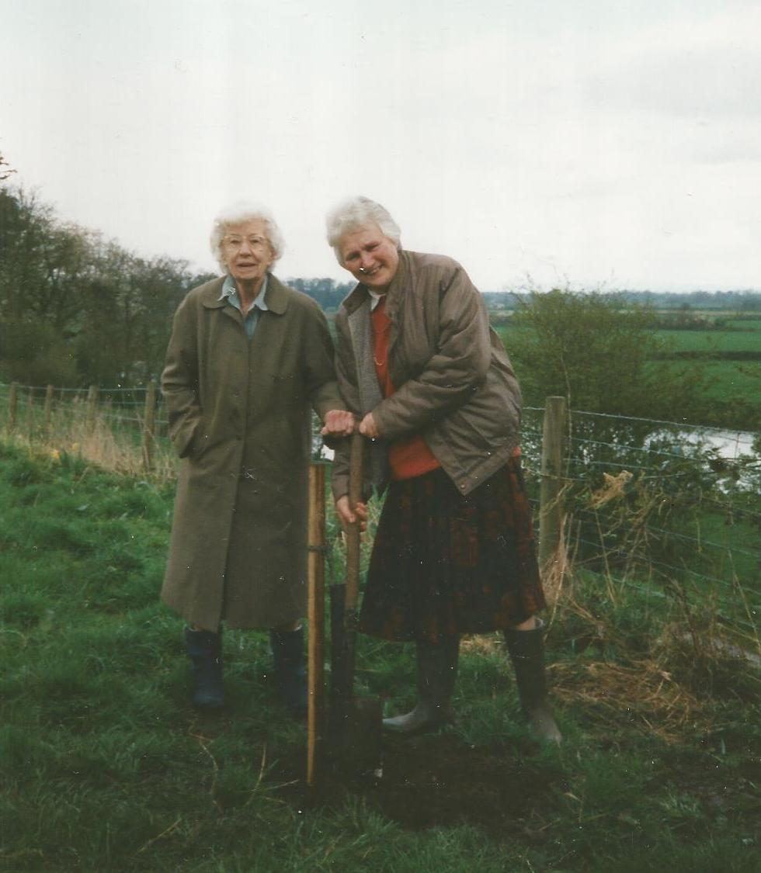

Margaret Vickers and Stella Hodgson planting an oak tree to celebrate the WI centenary

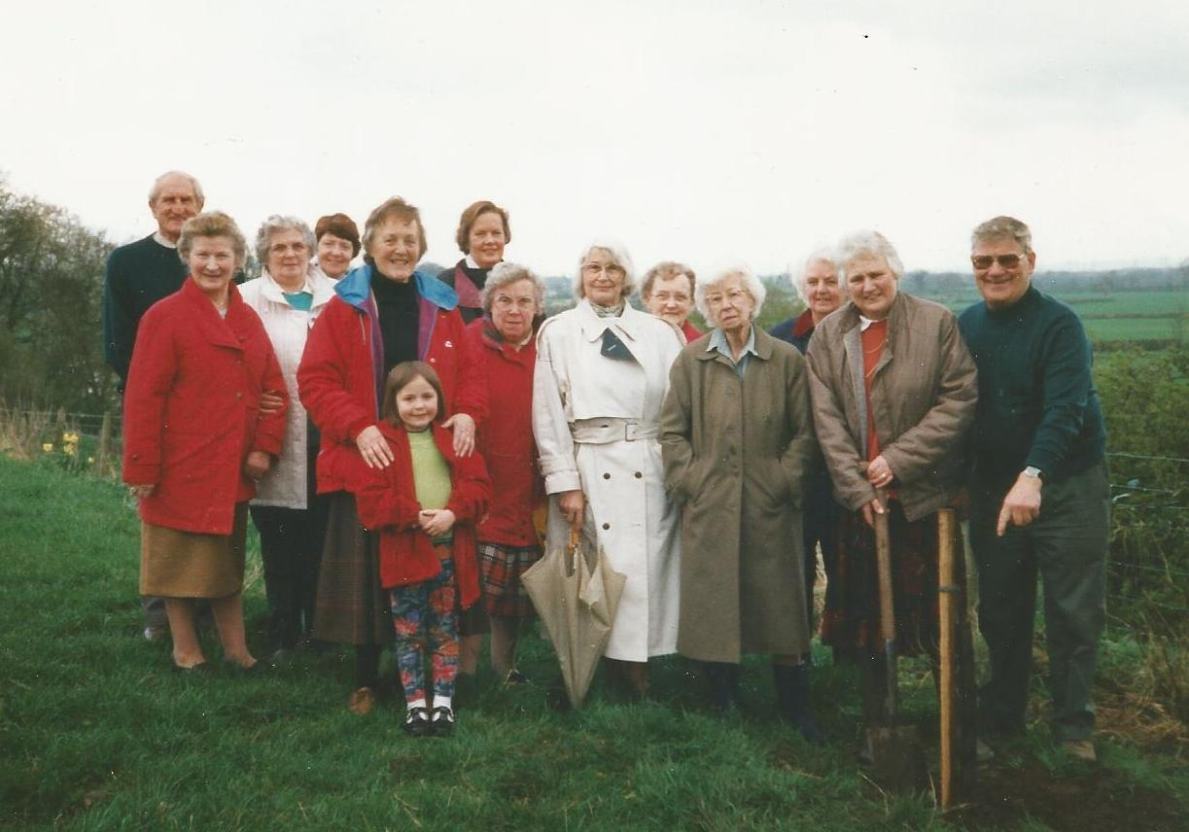
Left to right: Margaret Sewell, Margaret Roe, Margaret Parkinson, Sigrid Little, Cathy Stephenson, Thelma Burgess, Sadie Bell, Margaret Vickers, Stella Hodgson (WI President), Alan Hodgson

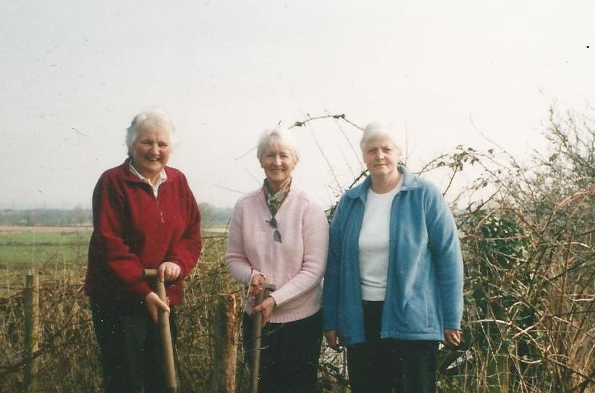

Stella Hodgson, Jenny Rayson and Margaret McKenna

