The development of the Pound or Pinfold at Kirkandrews on Eden

Location
The Pound is the enclosed piece of common land behind The Green in the centre of Kirkandrews on Eden.

Historical Use Information gained from residents in the Drover’s Rest on Thursday 21st May 2015

The Pound in Kirkandrews is the enclosed area of land in the centre of the village that some local residents refer to as the Pinfold and the Pumpfold.
Although the area is currently grassed with a few small trees and shrubs, surrounded by a low wall, in living memory, residents of the village recall that the area was secure, with gates and a hand pump and trough for animals to drink from. The pump and trough were situated inside the gate on the Beaumont road opposite Eden Farm. There were no trees in the enclosure.
The Pound was used as a temporary holding pen for animals to be kept safe overnight by drovers moving animals between the Solway marshes and Carlisle or on the way to the animal markets in Carlisle They would pay a small fee to hold their animals in the pound overnight and then stay at the Drover’s Rest in Monkhill.
The Pound was also used to hold stray animals found in the village until the owner of the animals could be found and then the animals released upon payment of a small fine.
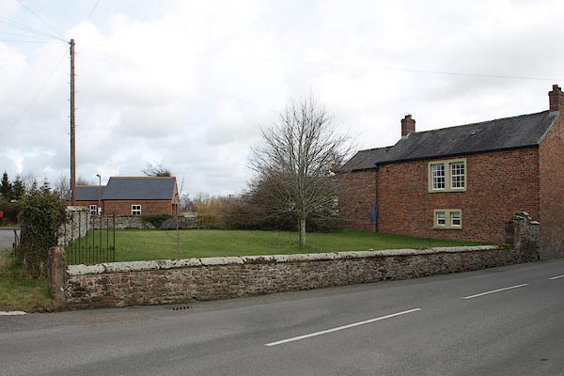
The Pound from Burgh road (2014)

General information about folds.
Managing farm animals through the farming year is a far from simple job. From the very earliest days when animals were first domesticated, there needed to be places where animals could be kept for protection from wolves and thieves, or to make sure they did not damage growing crops in fields.
It seems likely that these enclosures were used to corral sheep or cattle whenever necessary. From the Norman period, the feudal system of managing farmland communally meant that strict controls were placed on where and when animals could graze. The village pound or pinfold was created as a place where straying animals could be locked up until their owners paid a fine for their release.
The village pound survived the end of the medieval system of communal farming and shared grazing since animals still tended to stray if their owners failed to keep up their field boundaries. The pound was a handy place to keep animals while their owner was located even if fines were no longer imposed. Most of these little stone walled enclosures fell out of use after the implementation of the Enclosure Acts in the early 19th century. Little open grazing survived after this and land had to be securely walled or hedged.

More recently
In February 2015 during their meeting, the Parish Council planned to hold a meeting to discuss the future use of the pound with members of the parish in line with the Parish Plan.
The consensus of the meeting was to use the pound as a picnic area, with seating and an interpretation board giving information about Kirkandrews on Eden, for both visitors to the parish and locals residents.

In May in 2015 the Parish Council invited all those with memories and photographs of Kirkandrews as a working village to an afternoon tea at the Drovers Rest to share these memories and to make copies of any documents or photographs they might have.

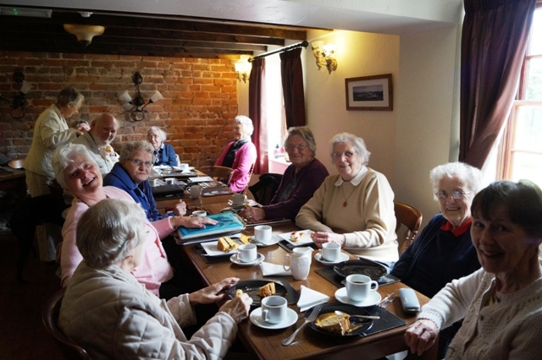
Photograph of the public meeting held in 2015 to discuss the Pound at the Drovers Rest, Monkhill.

From lleft to right): Mary Carr, Margret McKenna, Dot Reay, Stuart Swinsco, Kathleen Bowron (standing) Judith Swinsco, Cathy Stephenson, Margret Parkinson, Mary Fergusson, Margaret Rowe, Sadie Bell, Jean Wharton,

Following this meeting, there were many other smaller gatherings and visits to the archive to collect information and trace original maps and photographs.

Funding
Over the next couple of years funding was gathered for metal railings along the top of the wall running next to the main Kirkandrews to Monkhill road, together with funding for picnic benches on concrete hard standing and for an interpretation board.

Interpretation board design
Several meetings were organized to discuss the design and contents of the information board.
The final design is based on the sounds that might have been heard as one stood in the pound over the two thousand years from before the occupation by Rome, roman soldiers along Hadrian’s Wall, the church at Kirkandrews, the local village school, the smithy, the canal (1821-1853) and Carlisle & Silloth Bay Railway & Dock Company's (C&SBRDC) train-line (1854-1964) that ran through Kirkandrews on Eden, farming practices, rally for Kitchener in 1915 during the First World War and more recent occupiers.

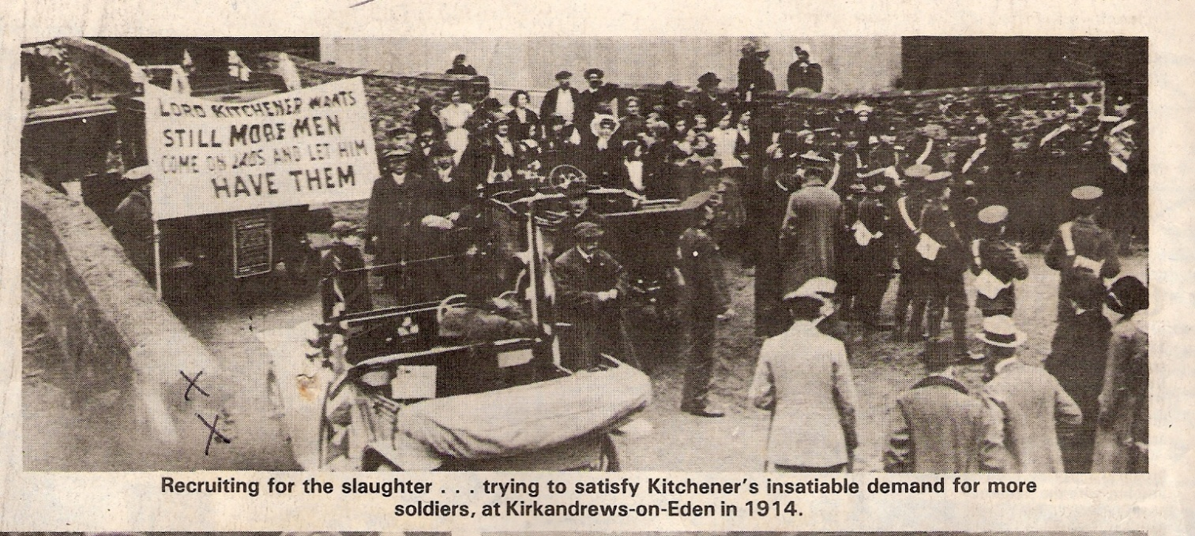
Newspaper cutting: outside the pound in 1914. (Probably incorrectly dated ?1915)

In February 2018, a gathering was organized so that a photograph could be taken of local parishioners that could also be included on the board.
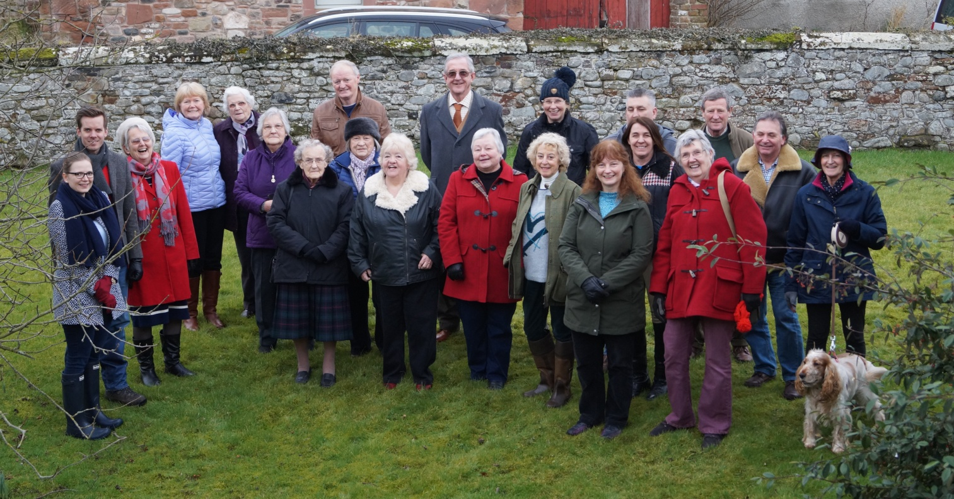
Photograph of parishioners taken in the pound in February 2018
(From left to right): Emily and Tim Roelich, Kathleen Bowron, Margret Milburn, Margaret Rowe, Alice Graham, Sadie Bell, Gordon Milburn, Mary Fergusson, Enid McIntosh, Harold Bowron, Linda Beattie, Eve Johnson, Kathryn Woolgar, Bryony Kirk, Ann Philips, Nigel, Judith Swinsco, Jim Johnson, Donald and Lynne Graham, Bertie

In March 2018 work begins on tidying up the Pound

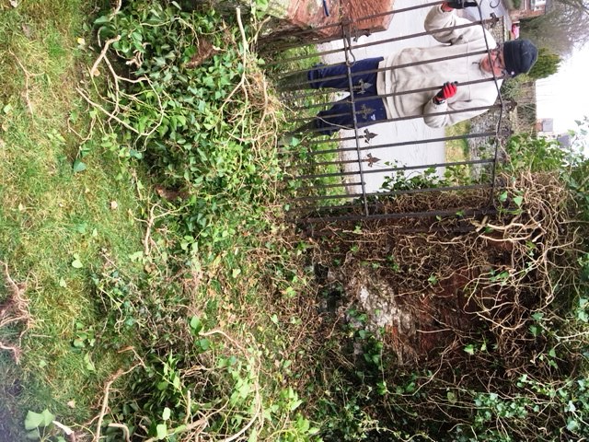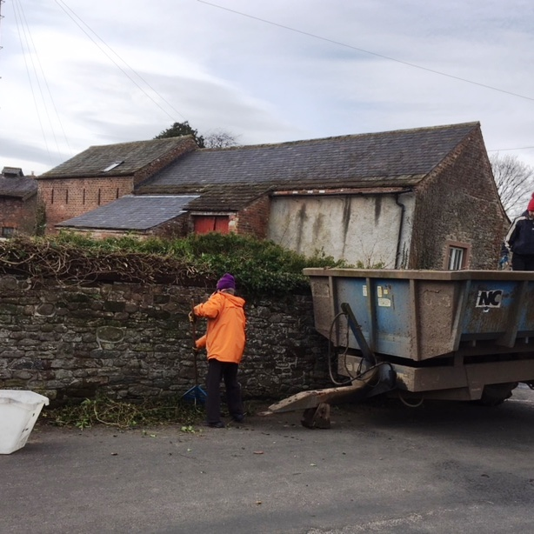
The pound is tidied up in preparation for the fixing of the railings.

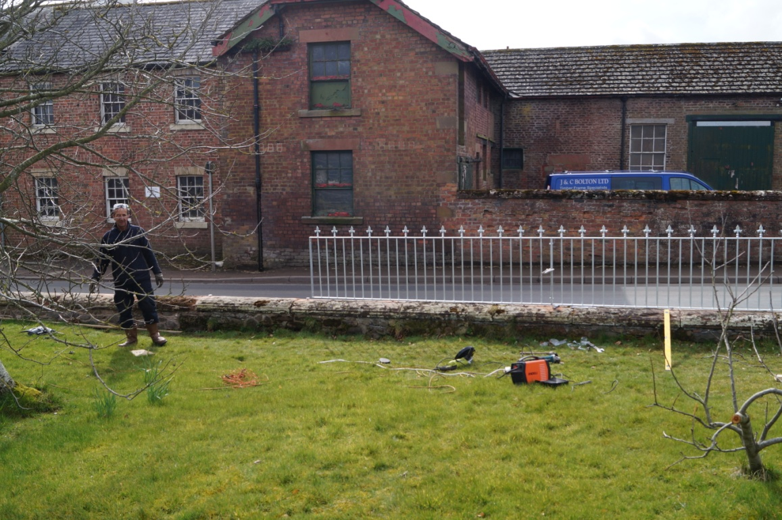

The galvanized fence starts to go up in preparation for the opening of the pound as a picnic area open to local residents and visitors (March 2018).

Photographs of picnic in May 2018

A picnic was organized on Bank Holiday Monday on 28th May 2018 to celebrate the opening of the Pound and a picnic area with benches and interpretation board.

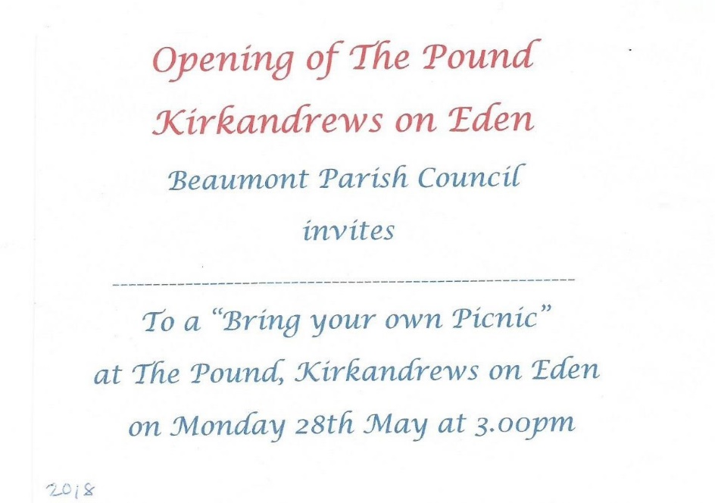
An open invitation to residents of the parish was included in the Parish Magazine and personalized invitations were issued to everyone involved in the project.

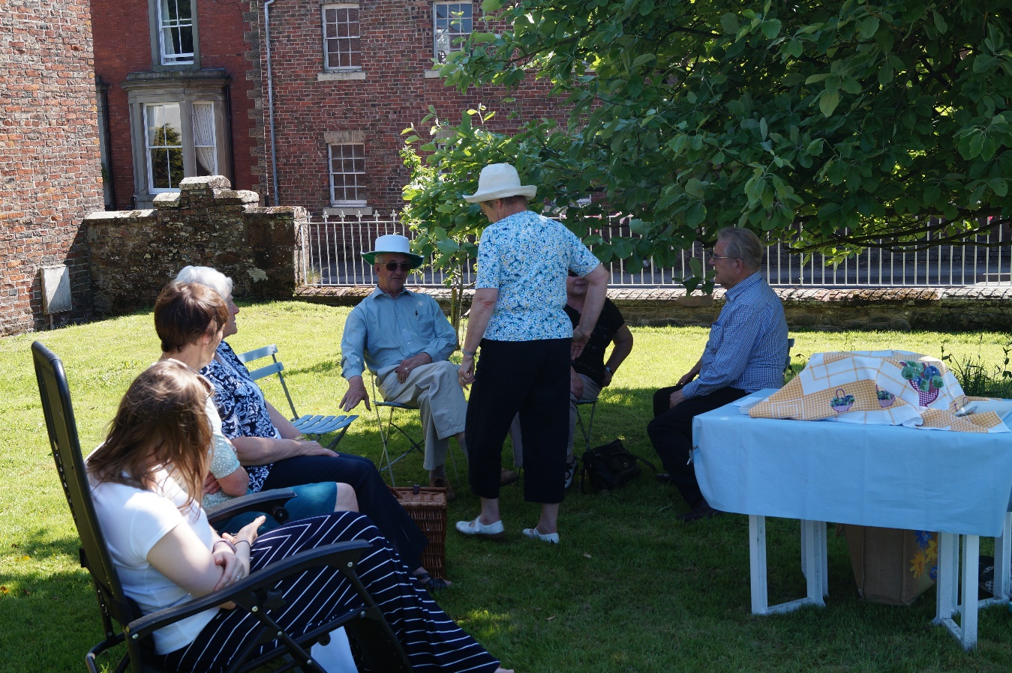
From left to right: Emily Roelich, Jean Wharton, Margaret McKenna, Harold Bowron, Trevor Allison, Kathleen Bowron (standing)
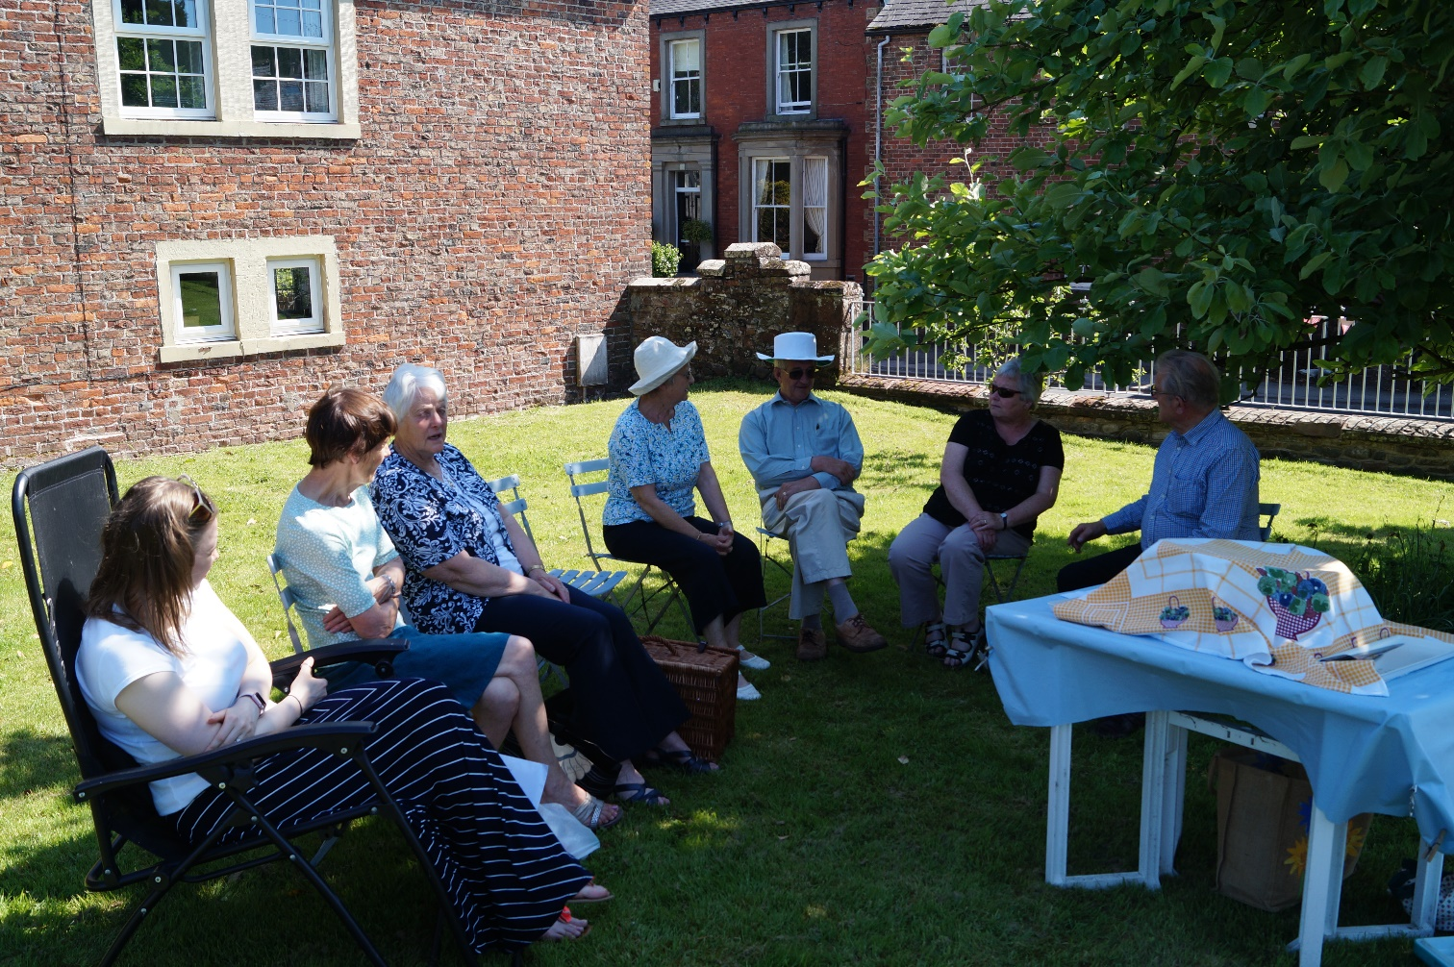
From left to right: Emily Roelich, Jean Wharton, Margaret McKenna, Kathleen Bowron, Harold Bowron, Linda Beattie, Trevor Allison.

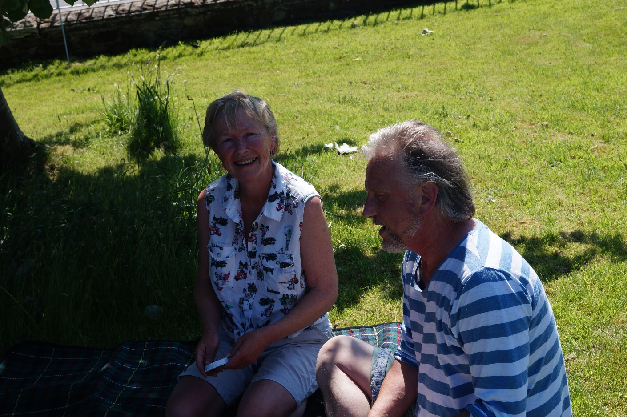
Liz Morton and Chris Crabtree
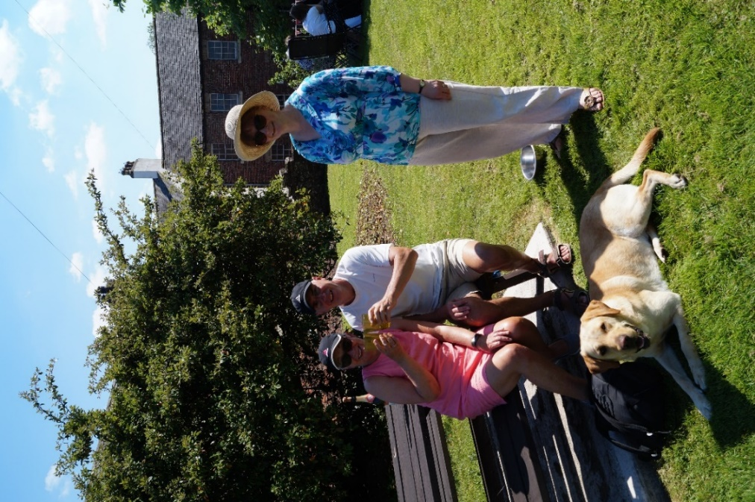
Mrs. and Mr. Neil Bowen (interpretation panel designer) and Bryony Kirk

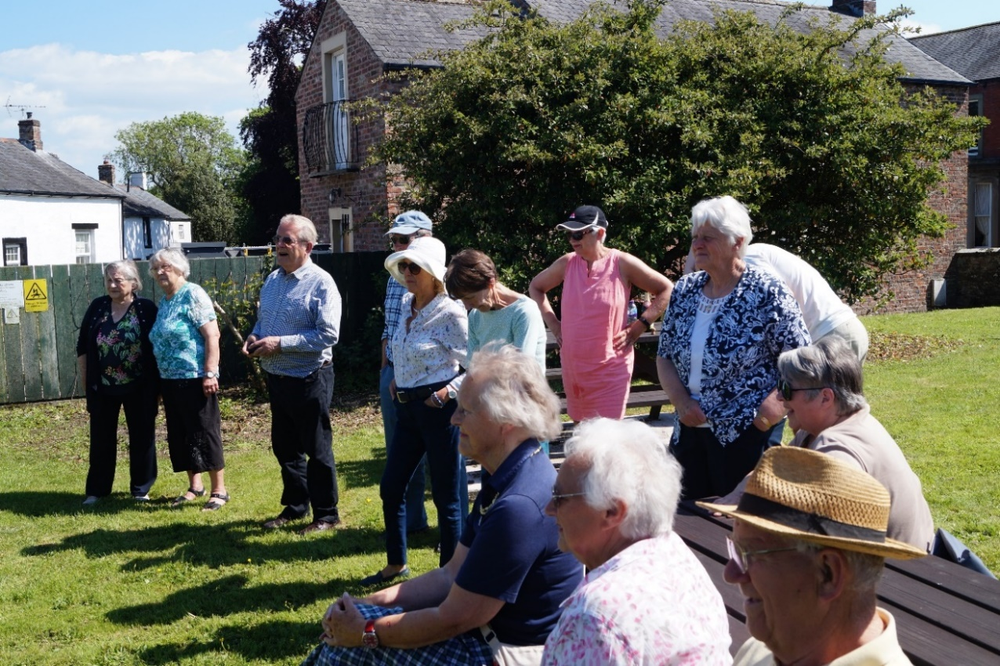
From left to right: Mary Fergusson, Alice Graham, Trevor Allison, Jim Johnson, Eve Johnson, Jean Wharton, Mrs. Bowen, Margaret McKenna. Seated: Margaret Parkinson, Stella and Alan Hodgson, Rona Salkeld,

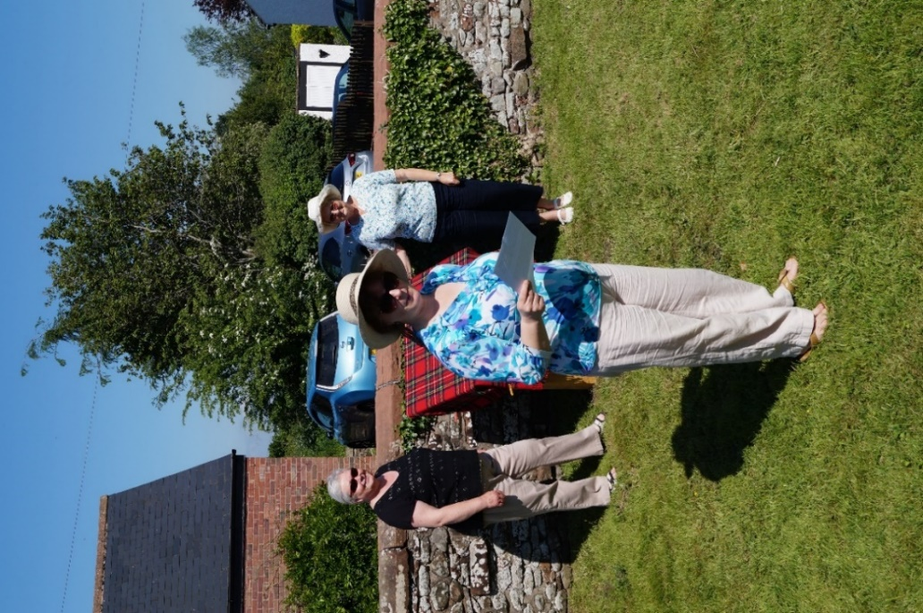
Panel hidden: Linda Beattie, Bryony Kirk, Kathleen Bowron.

Bryony gave a short speech about the history of the Pound and thanked all those who helped with the work to open the Pound as a picnic area, before the new interpretation board was revealed. The panel shows several scenes of sounds that would have been heard in the area.

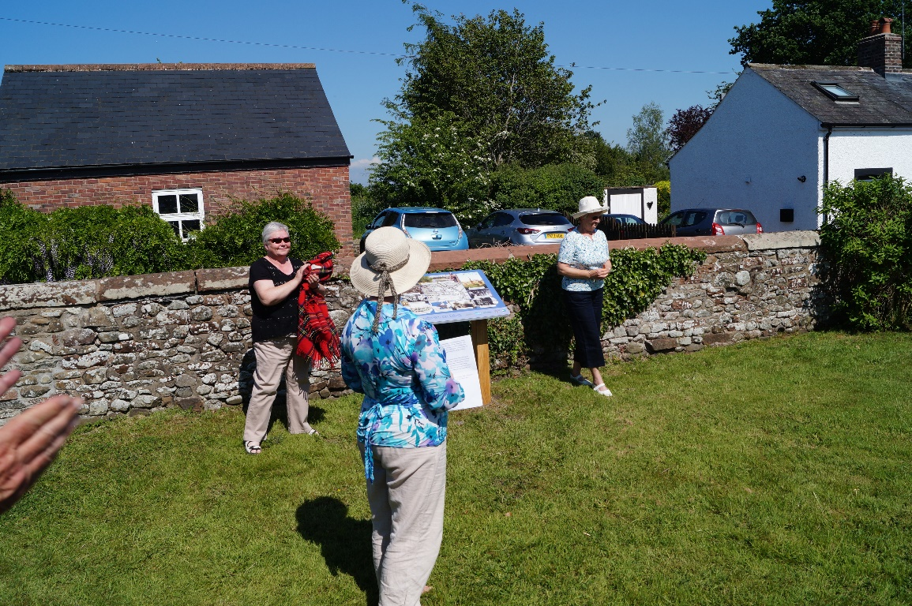
Panel revealed: Linda Beattie, Bryony Kirk, Kathleen Bowron,

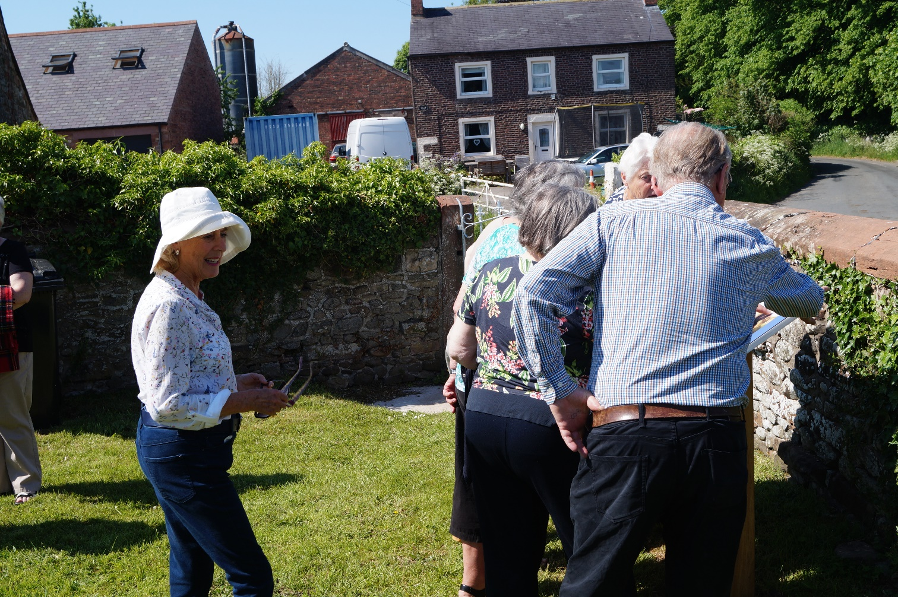
Even Johnson, looks on as others view the interpretation panel

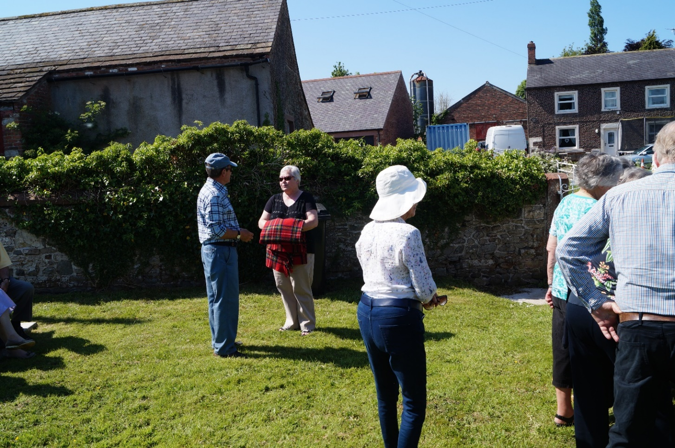
From left to right: Jim Johnson, Linda Beattie, Eve Johnson

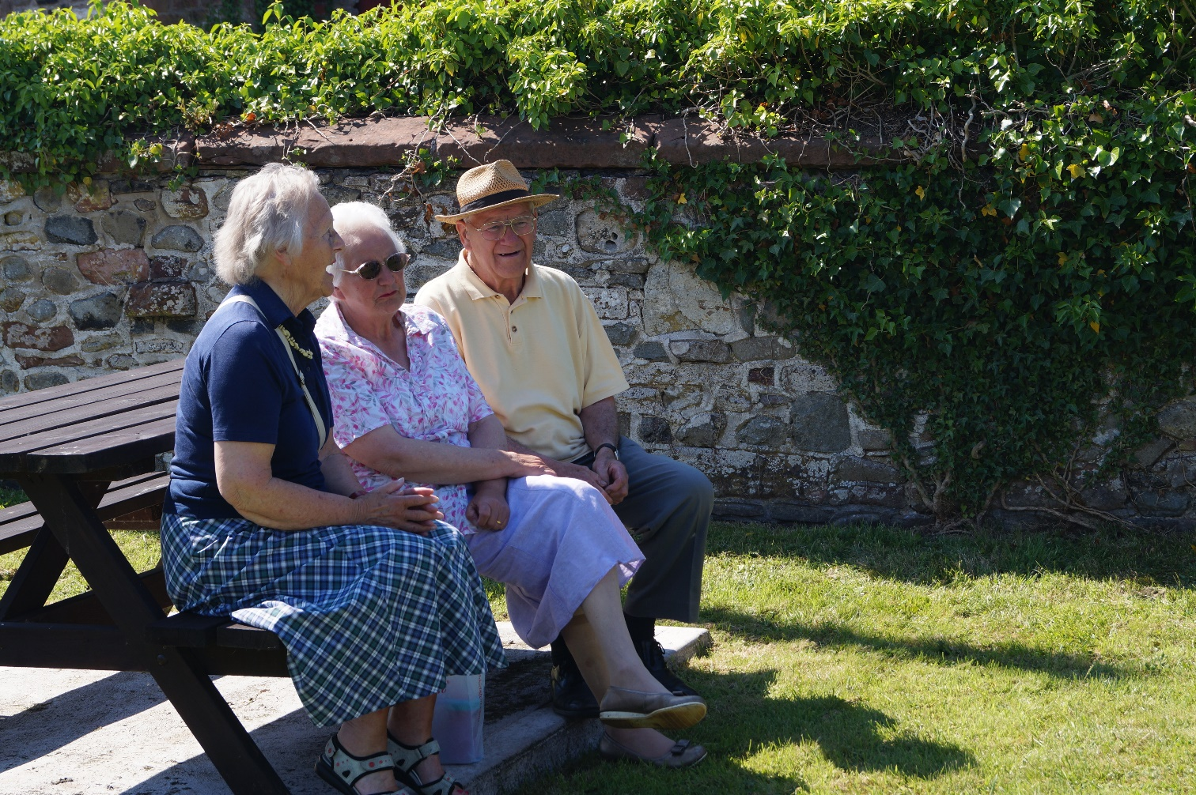
Margaret Parkinson, Stella Hodgson, Alan Hodgson

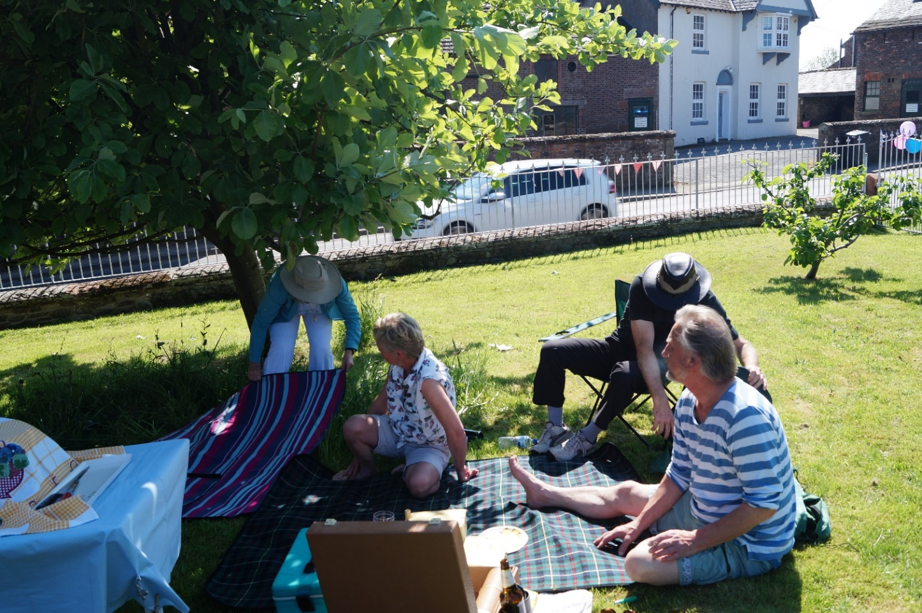
Margaret Milburn, Liz Morton, Chris Crabtree, Gordon Milburn

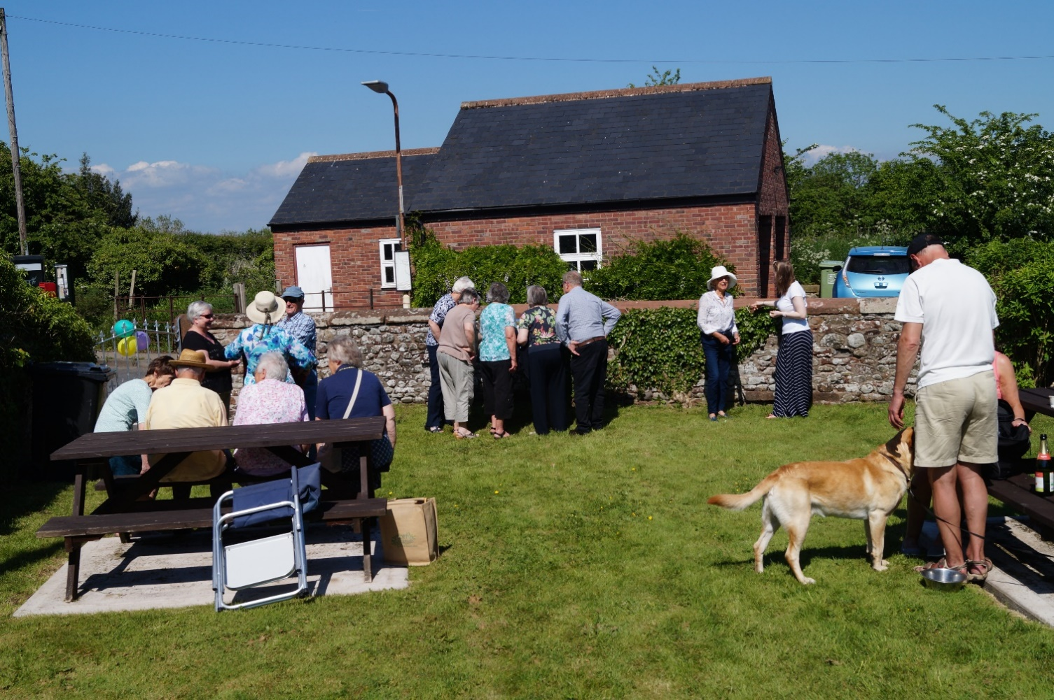

About 25 people attended the picnic afternoon
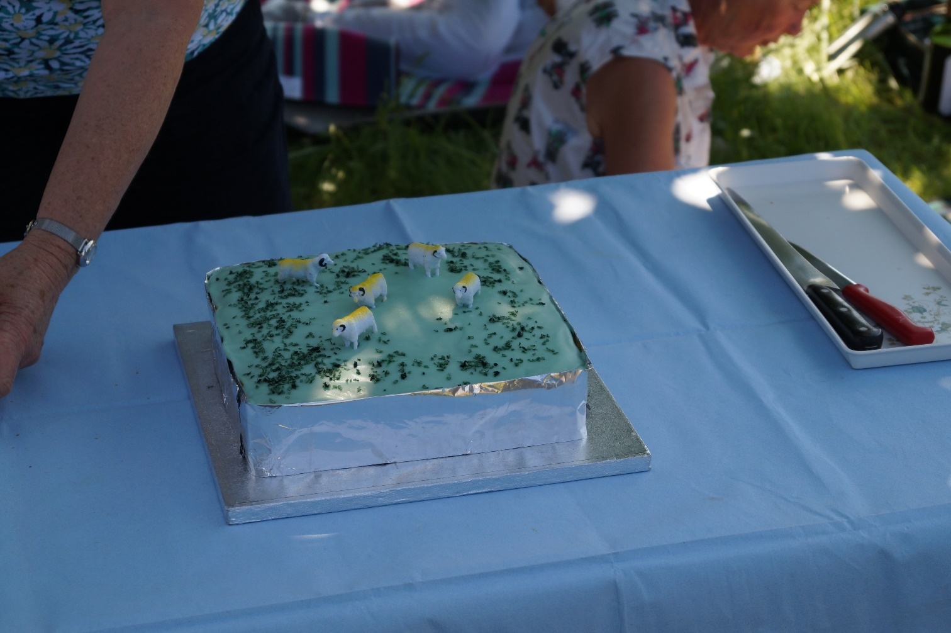
A cake was made to celebrate the opening

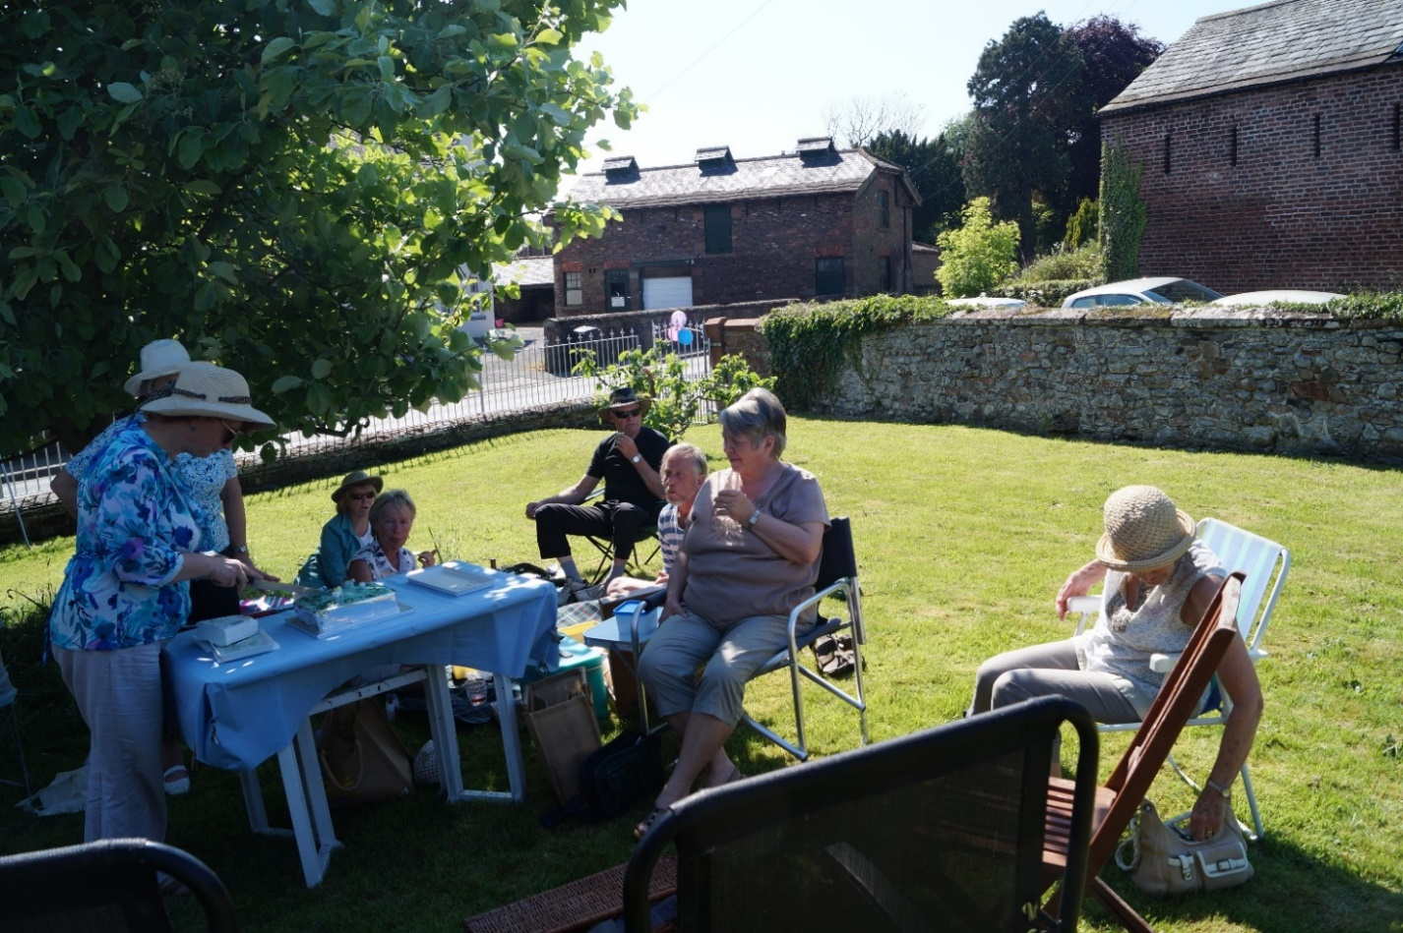
From left to right: Bryony kirk, Kathleen Bowron, Margaret Milburn, Liz Morton, Gordon Milburn, Chris Crabtree, Rona Salkeld, Lynne Graham

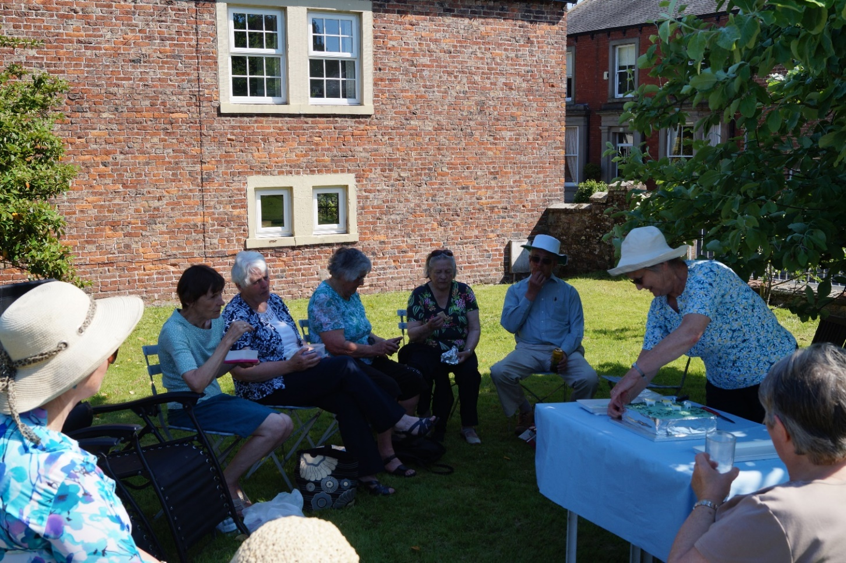
From left to right: Bryony Kirk, Jean Wharton, Margaret McKenna, Alice Graham, Mary Fergusson, Harold Bowron, Kathleen Bowron, Rona Salkeld.

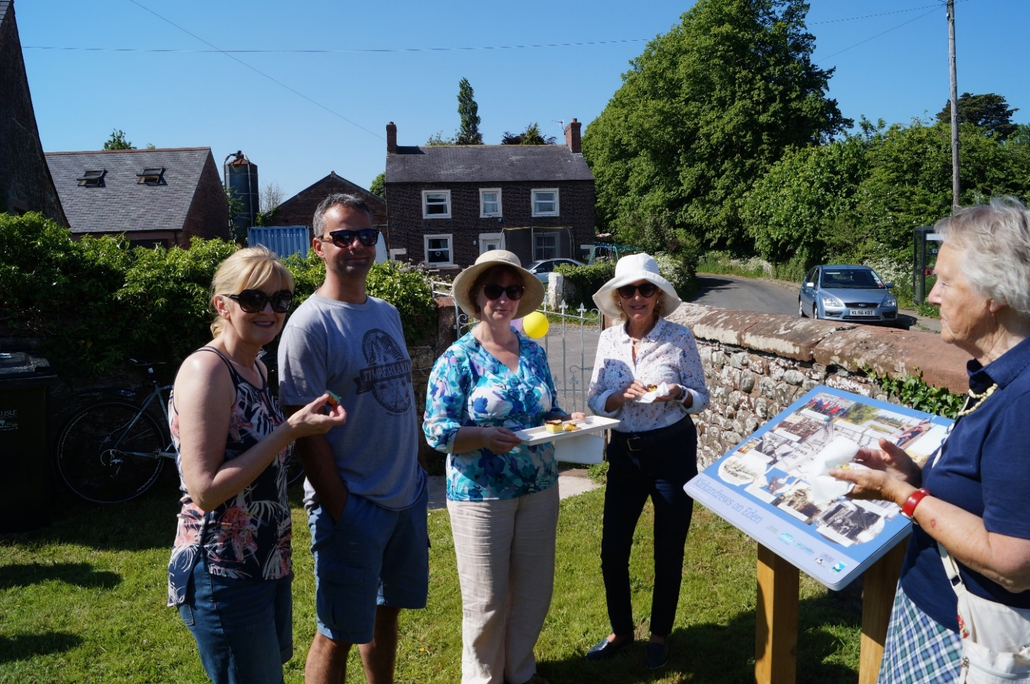
Liz and Stuart Williamson, Bryony Kirk, Eve Johnson, Margaret Parkinson

