Memoirs of a Lady Motorist by Olivia Graham 1916
A Centurian
The other day I visited Mrs. Jane Armstrong, of Beaumont, near Carlisle, who lately attained her 100th birthday, having born on June 15th 1815 (the date of the historical ball before the battle of Waterloo).
I found the old body wonderfully active. I had a photograph taken of her seated in my Argyll car. She is so independent she would hardly allow anyone to assist her, and kept reiterating, “I could walk to Carlisle” (five miles distant).
I don’t think she quite understood being photographed, for it was difficult to persuade her to keep quiet, and when in the car she set off industrially to polish up the brass with her handkerchief! I wondered if she is the first centurion to have been in a motor car?

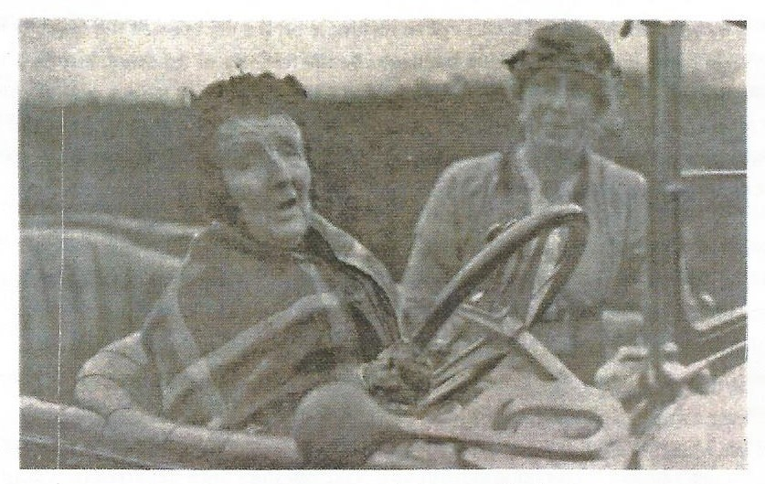
Mrs Armstrong aged 100, at the wheel

