Meeting at The Drovers Rest to discuss the future of the Pound in Kirkandrews in May 2015

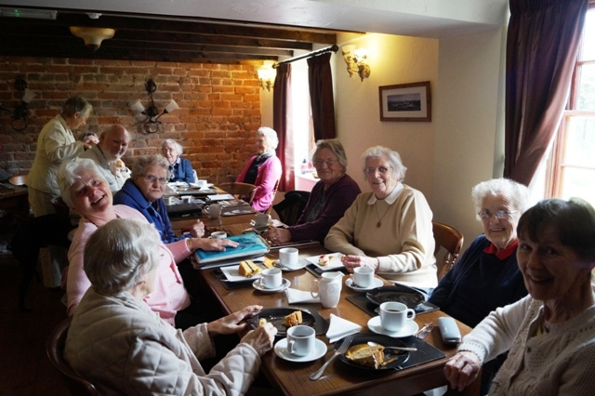

??, Margaret McKenna, ?, Stuart Swinsco, Kathleen Bowron (standing), Judith Swinsco, Cathy Stephenson, Margaret Parkinson, Alice Graham, Margaret Rowe, Sadie Bell, Jean Wharton.

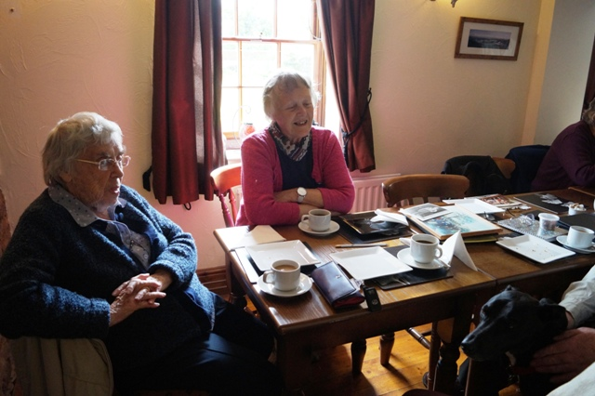
Cathy Stephenson, Margaret Parkinson

