Beaumont Parish Hall Community Sing-along

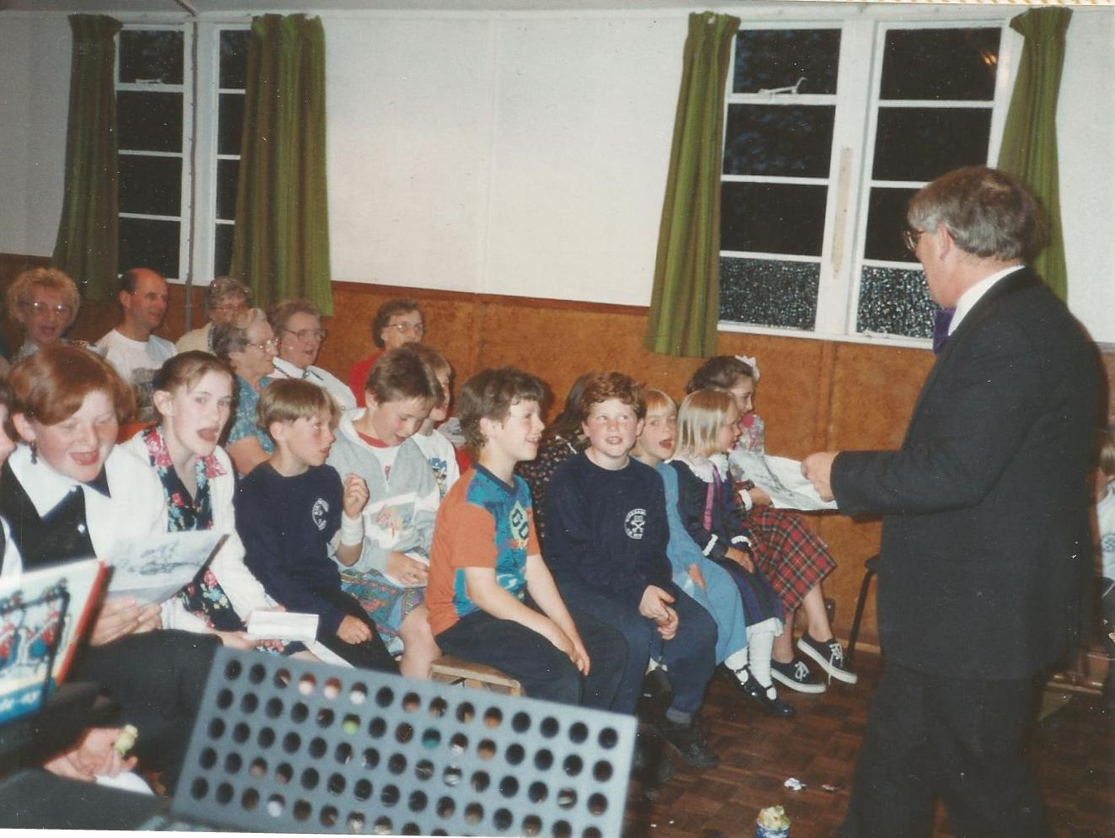
Alan Hodgson comperes the Cumberland Night

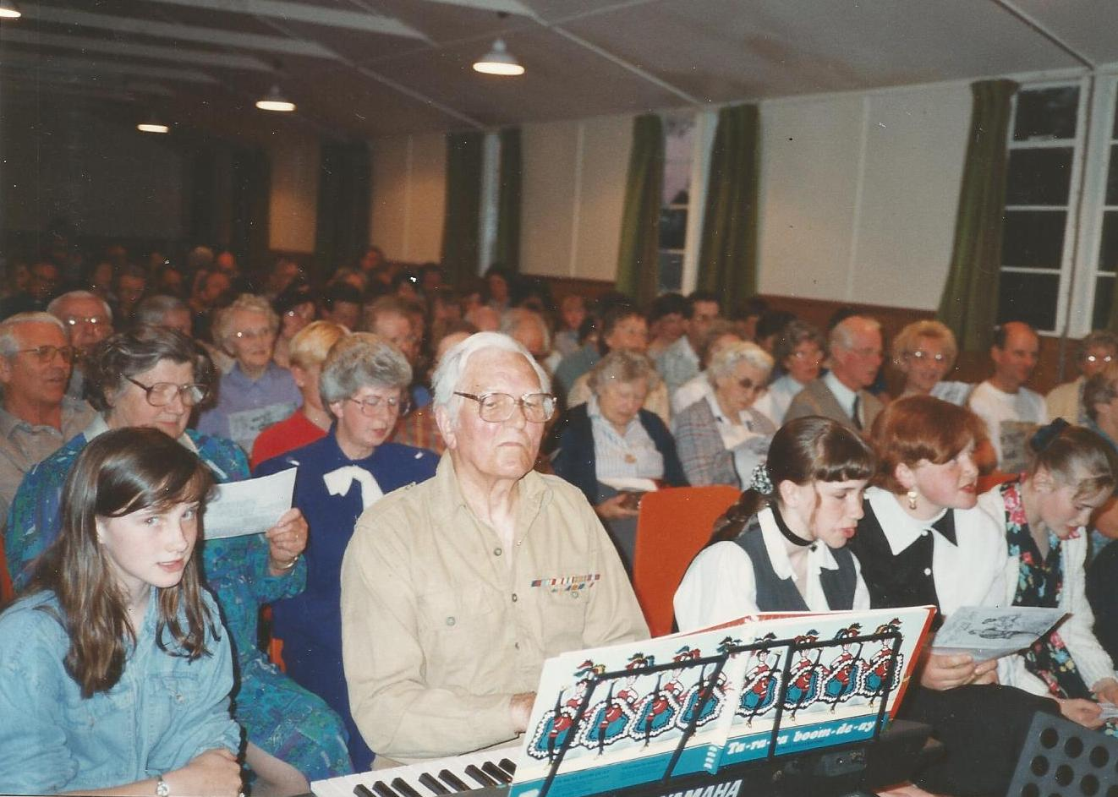
Rex Gregson (Burgh by Sands)

