Beaumont Parish Hall repairs and on ongoing maintenance
To the roof in 2008

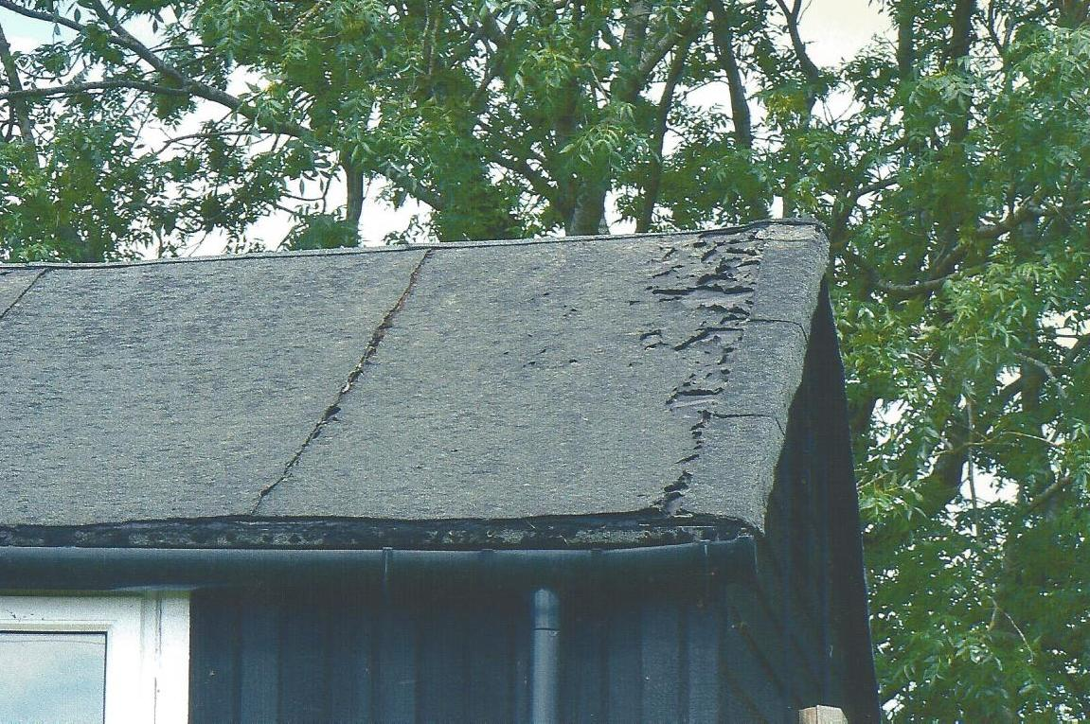

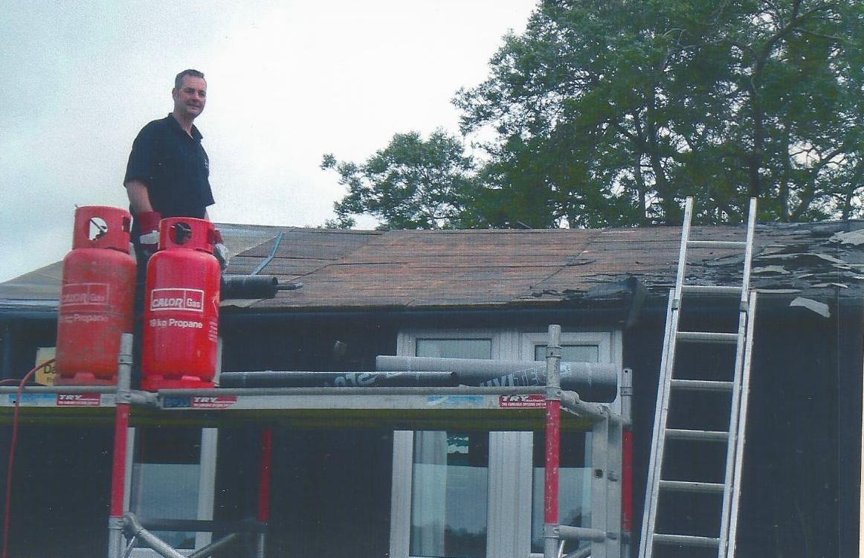
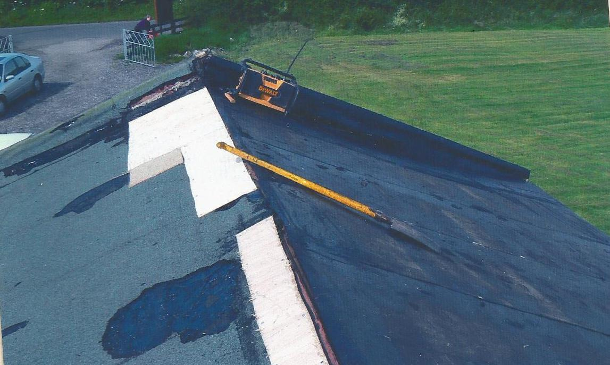

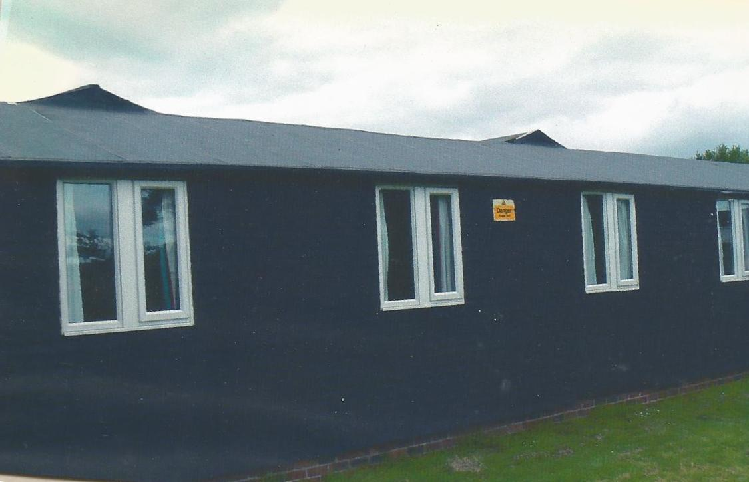

Work party clean the outside and creosotes the walls

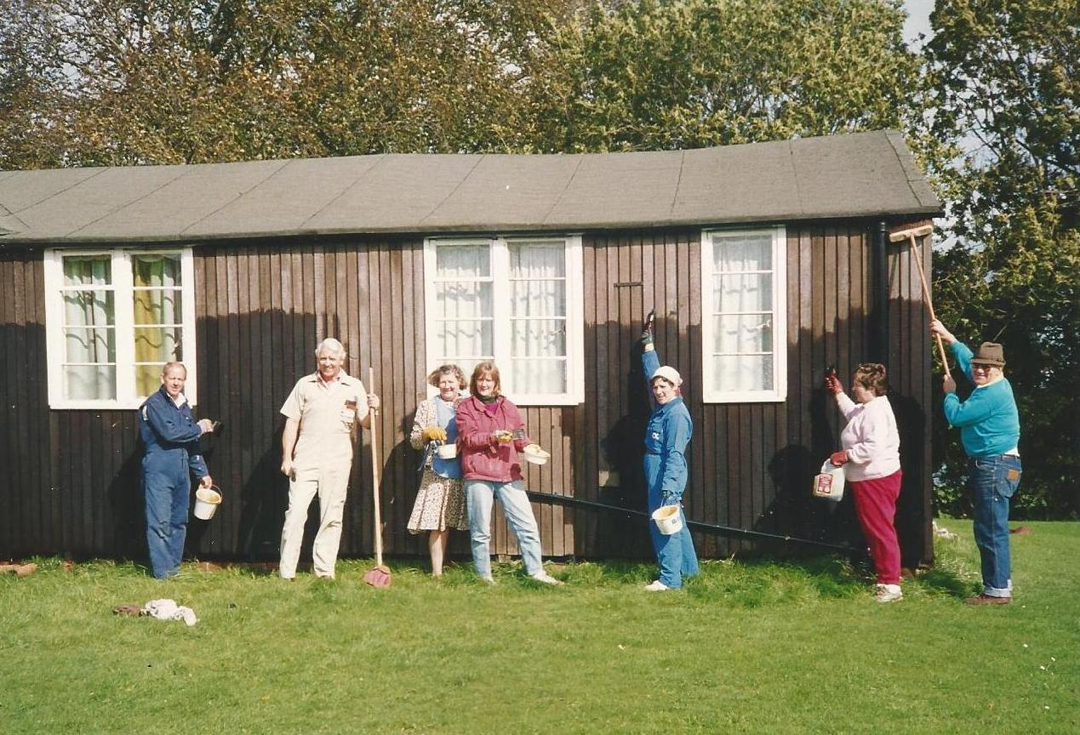
Creosoting the wooden walls, from left to right: Jimmy Rayson, Gordon Little, Betty Martin,
Corrine Riley, Maryann Baxter, Rona Salkeld, Alan Hodgson

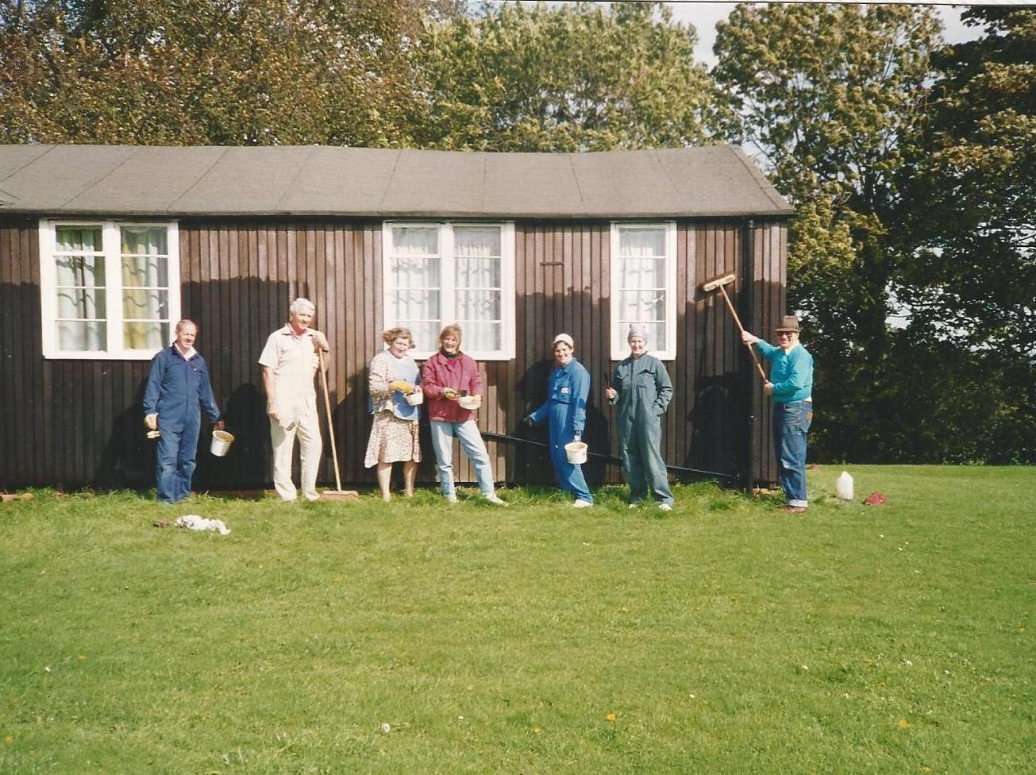
Creosoting the wooden walls, from left to right: Jimmy Rayson, Gordon Little, Betty Martin,
Corrine Riley, Maryann Baxter, Jenny Rayson, Alan Hodgson

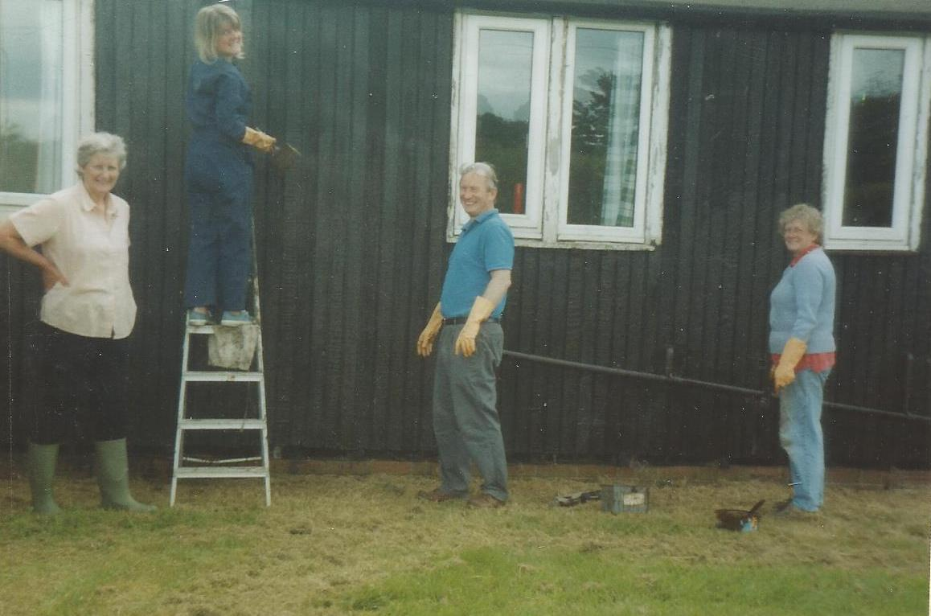

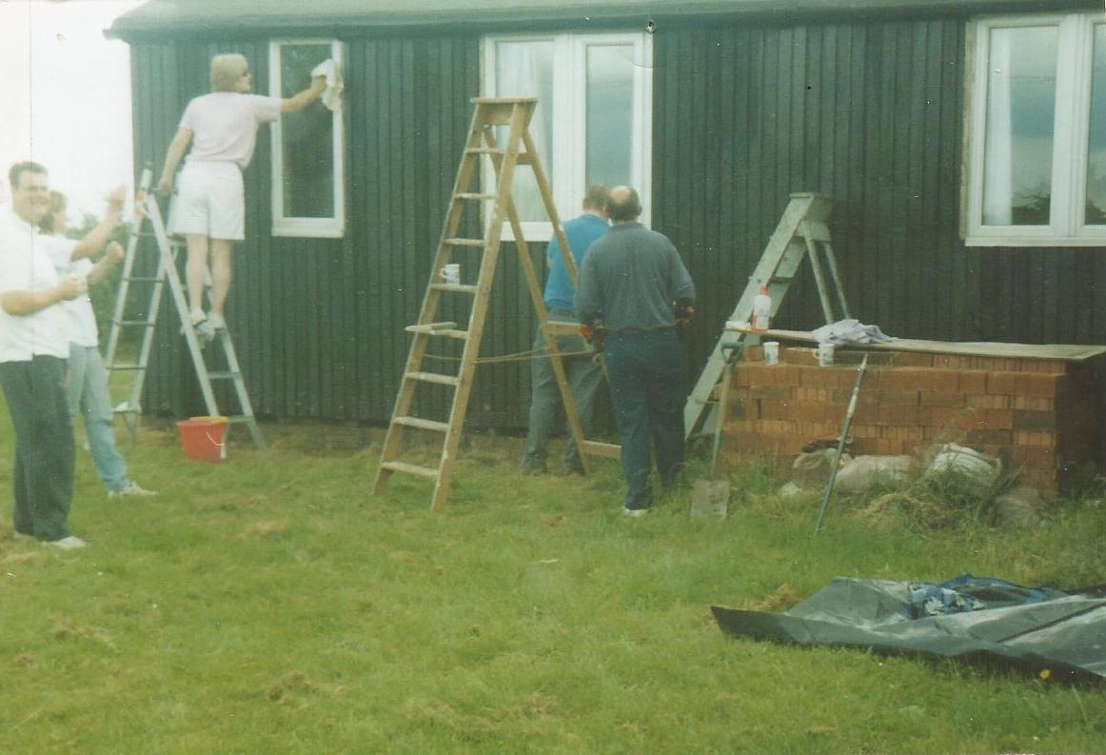
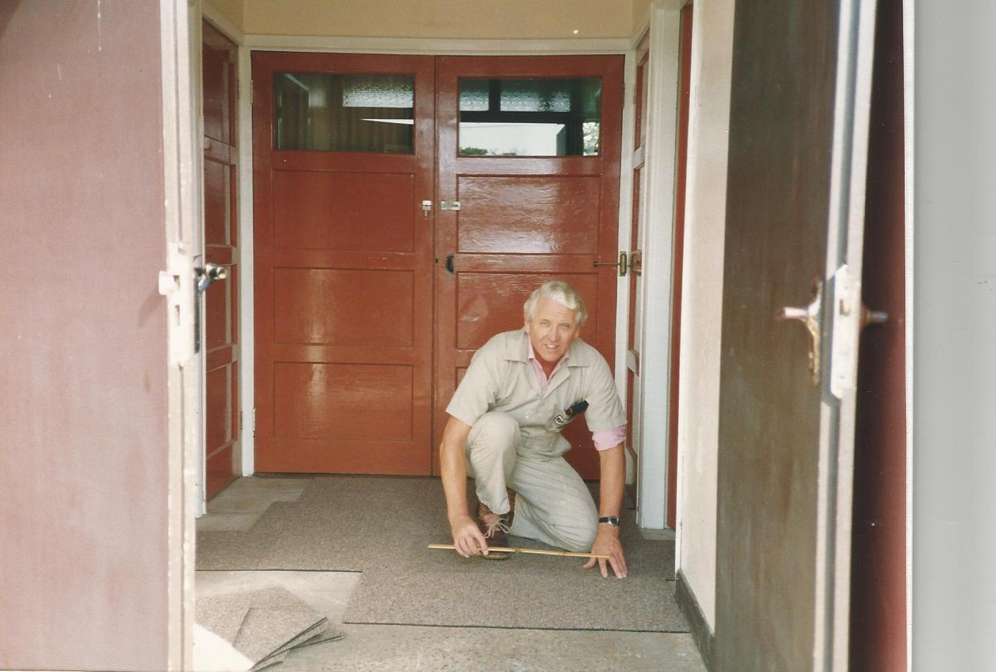
Gordon Little carpets the entrance floor

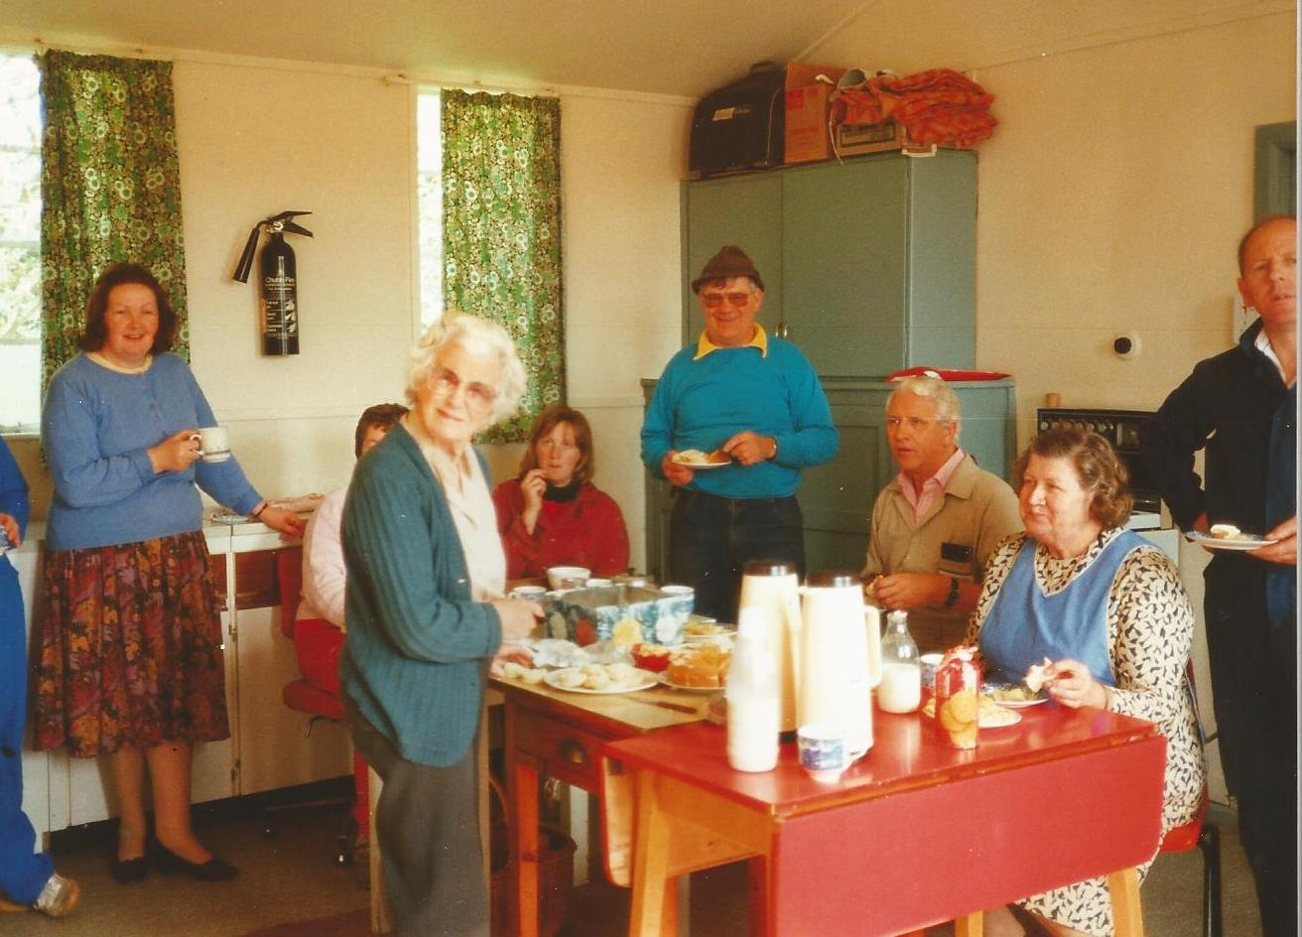
Tea break, from left to right: Dorothy Hope, Rona Salkeld behind Margaret Vickers, Corrine Riley, Alan Hodgson, Gordon Little, Betty Martin, Jimmy Rayson

