Beaumont Parish Hall Indoor Bowls Club in 1997

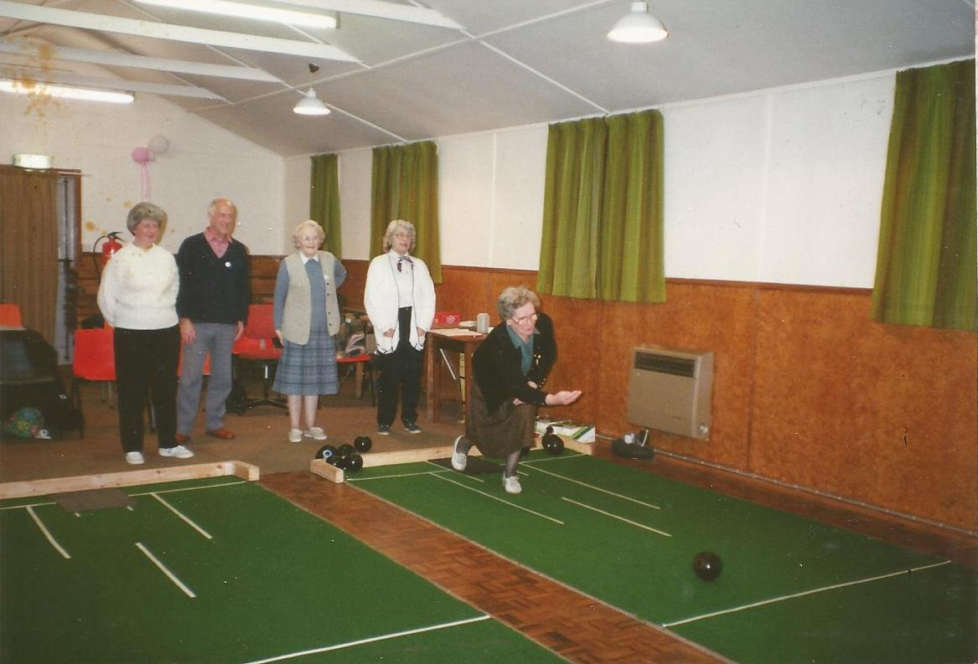
Ann Middleham, Sydhill, Iris Nicholson, Thelma Burgess, Mary Norman

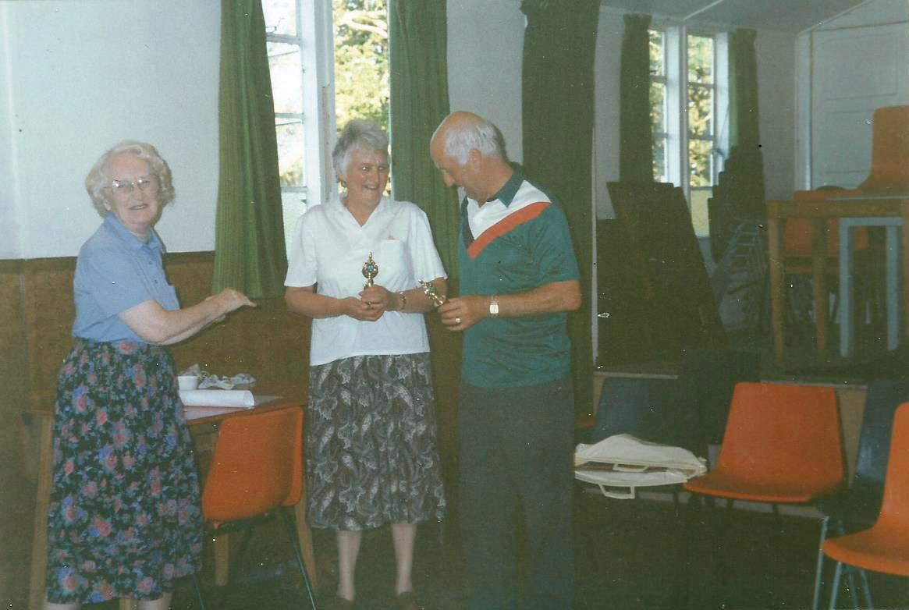
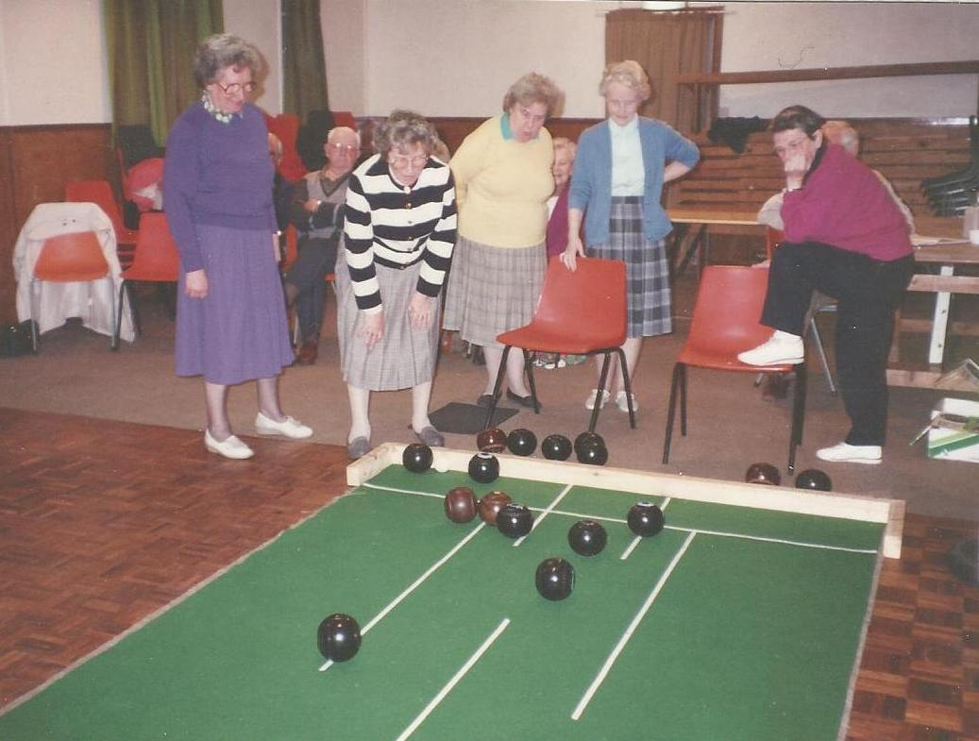
Craster Mawbray, Myra Hill, Ray Parkinson, Cathy Stephenson, Jean Wharton,
Syd Hill and Ann Middleham

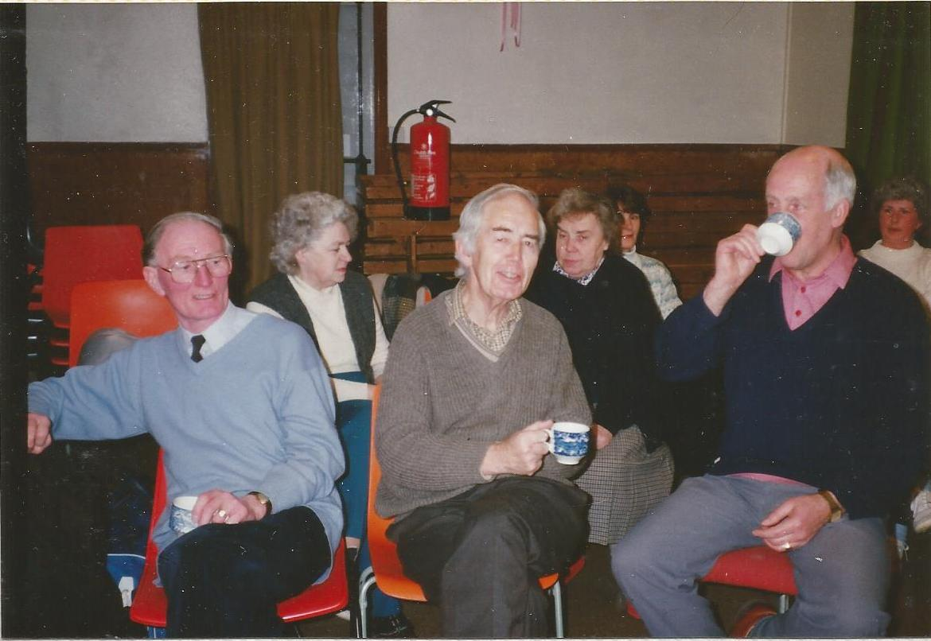

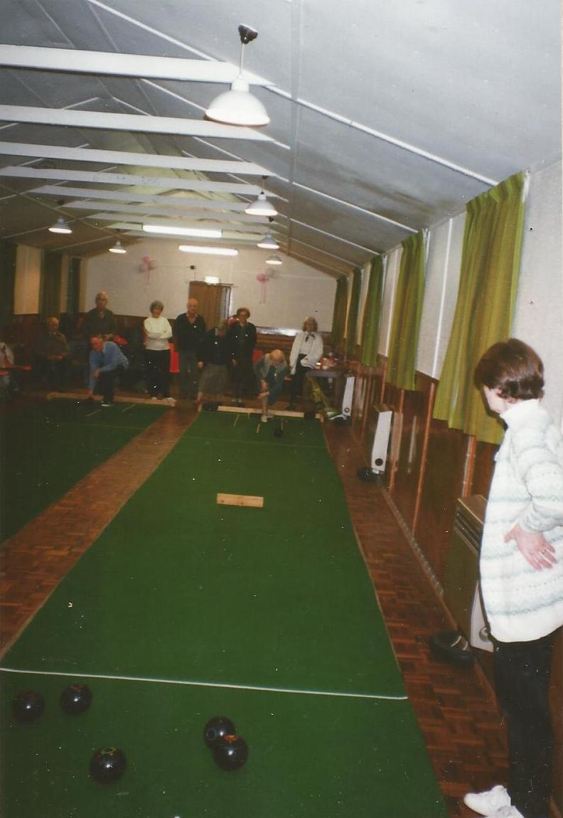

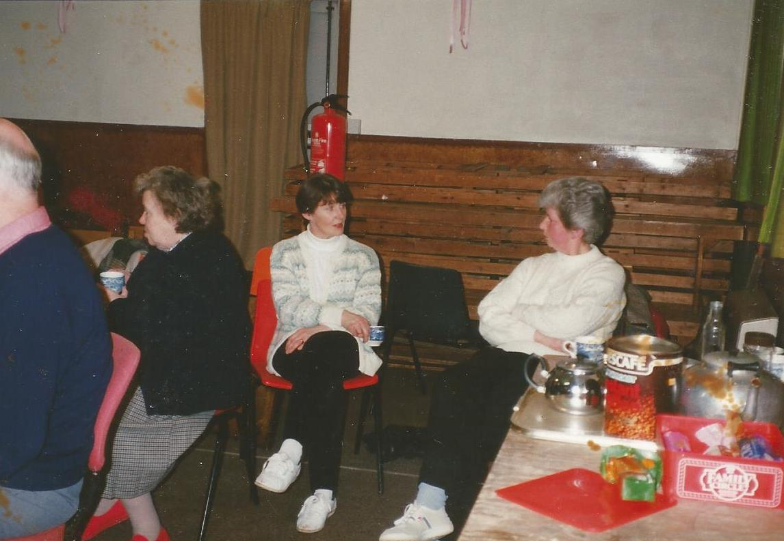
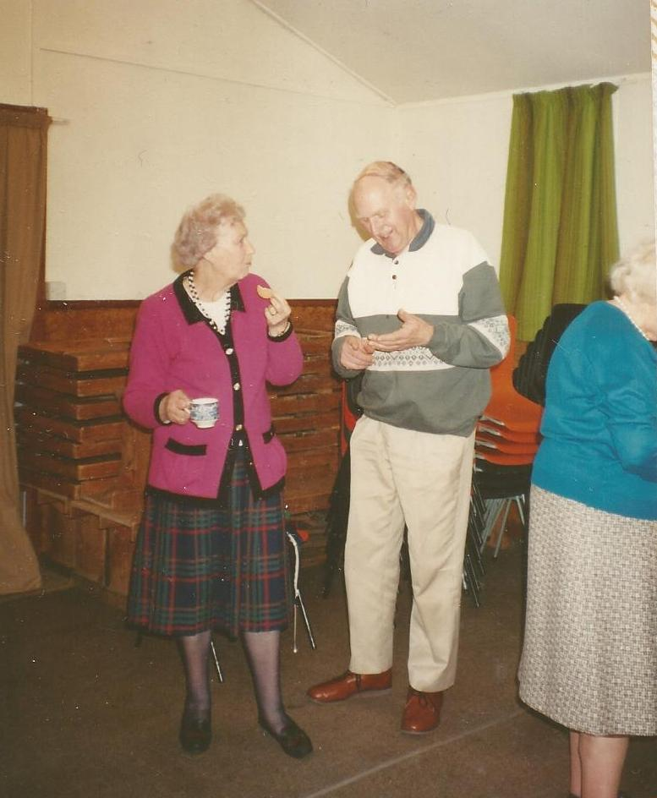

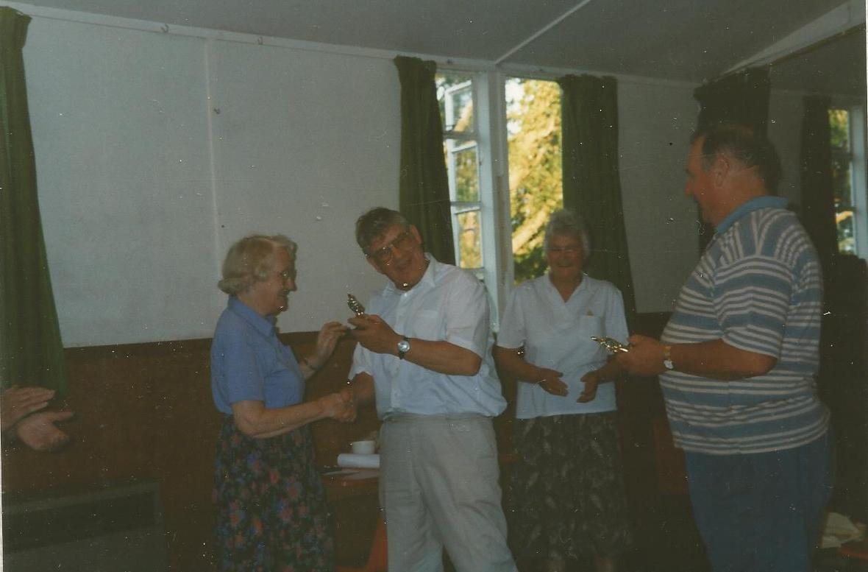

Iris Nicholson, Alan Hodgson, Stella Hodgson, Barrie Goldings
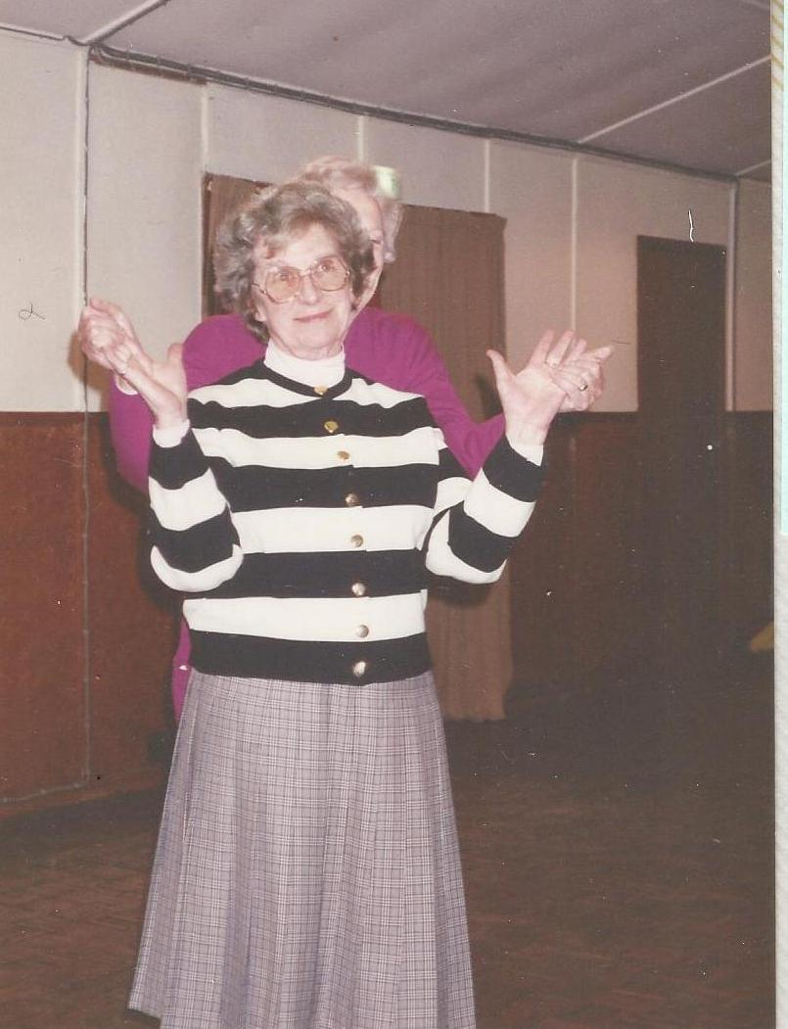
Kay Parnaby

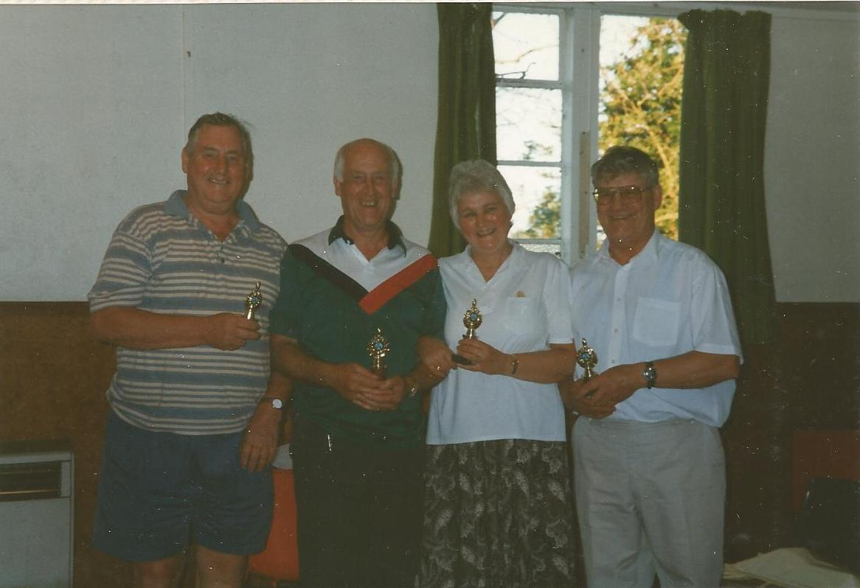
Bowls champions 1997: Syd Hill and Stella Hodgson
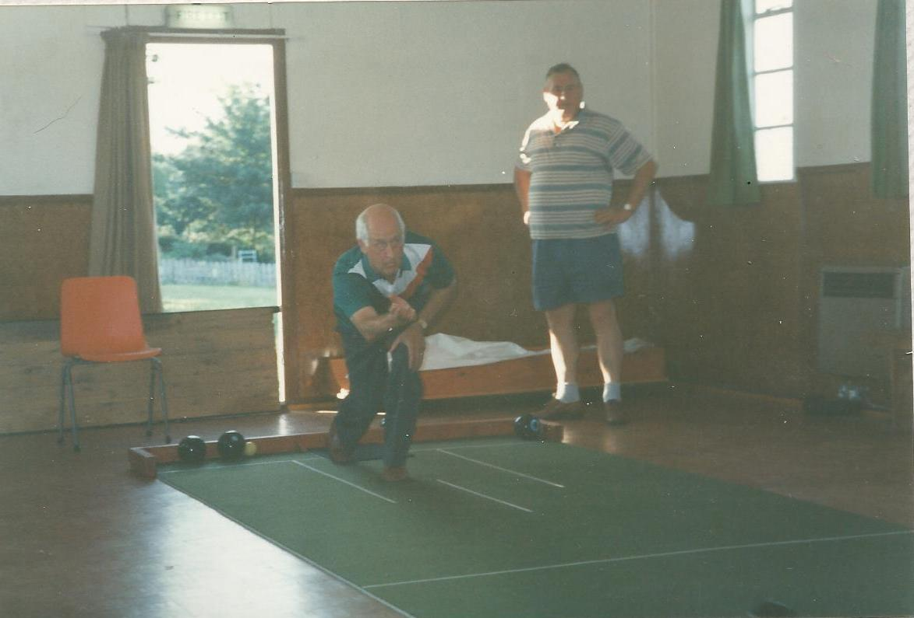
Runners up: Barrie Goldings and Alan Hodgson

