Beaumont Parish Hall Commemorative tree planting

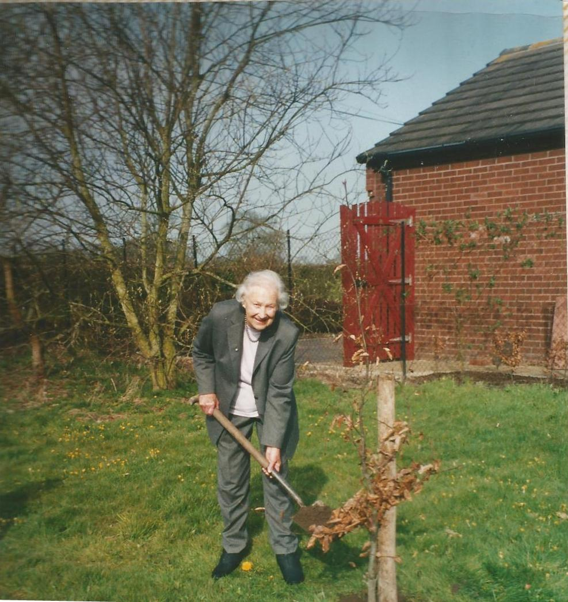

Mary Reeve plants a commemorate tree for Herbert Reeve, past chairman of Beaumont Parish Hall

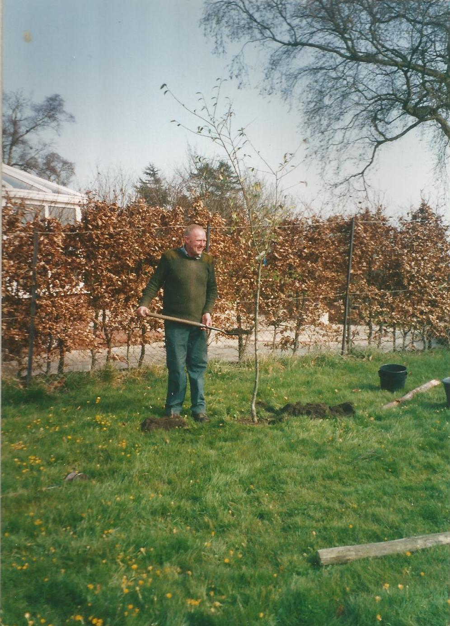
John Reay plants a commemorative tree

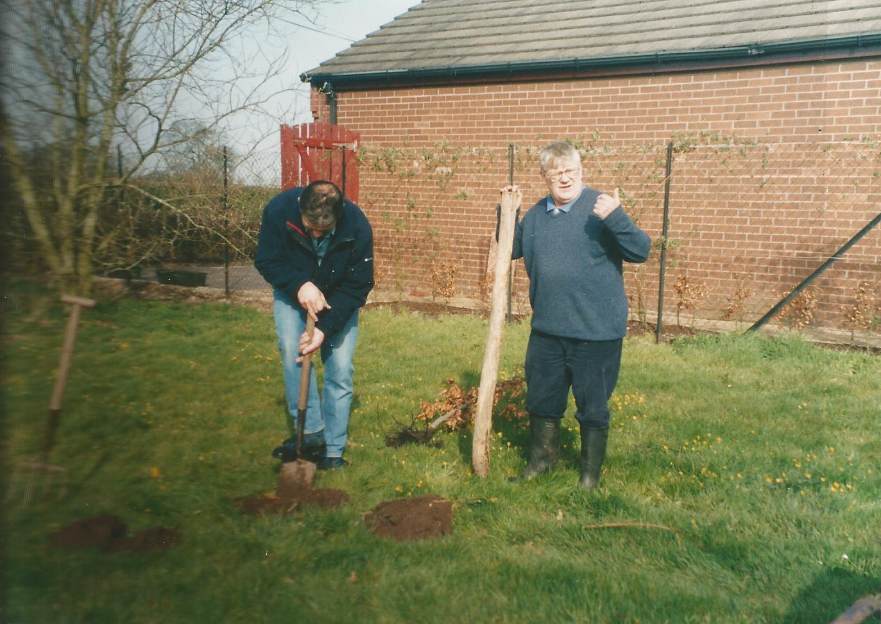
James Roe plants a tree as chairman of Beaumont Parish Hall Committee with Alan Hodgson helping

