Beaumont Parish Hall outside work party March 2022

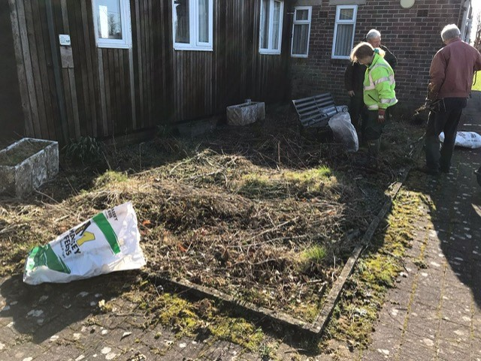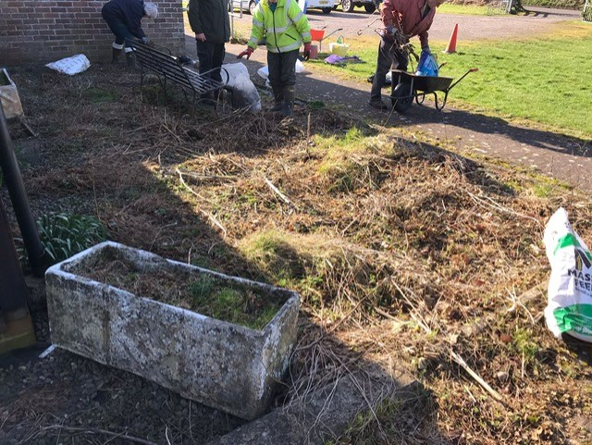
Bryony, Harold, Dawn, Judith, Tudor and Malcolm make a start tidying the seating area outside the hall.
Tree planting to commemorate the platinum jubilee of Queen Elizabeth II
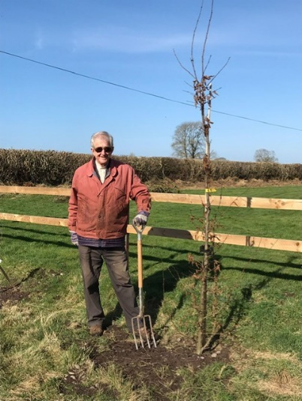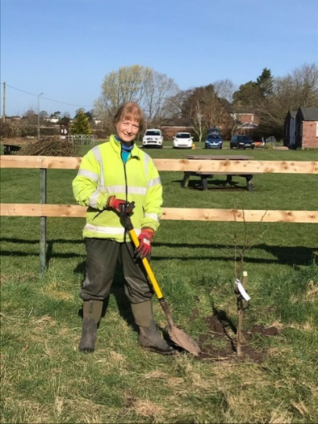
Harold plants a hornbeam on behalf of the Parish Hall and Bryony plants a crab apple on behalf of Beaumont Parish Council.
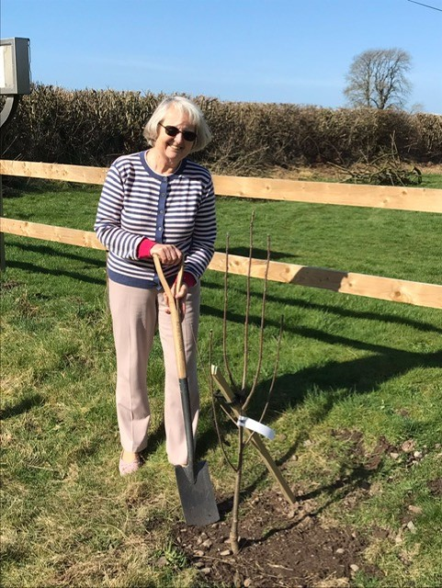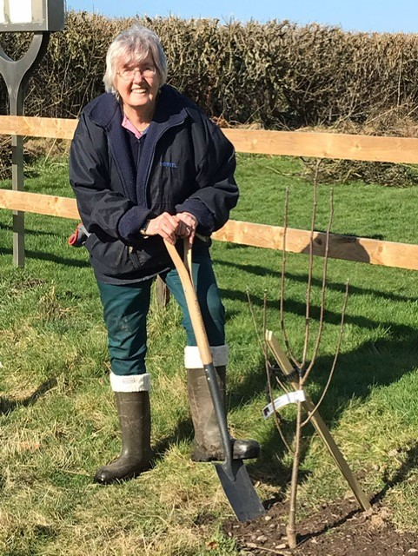
Kathleen and Judith plant a rowan on behalf of the Kirkandrews on Eden W.I.

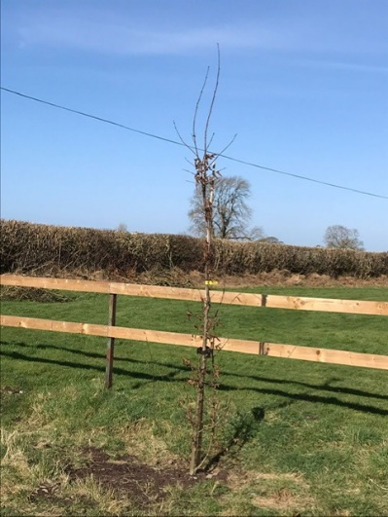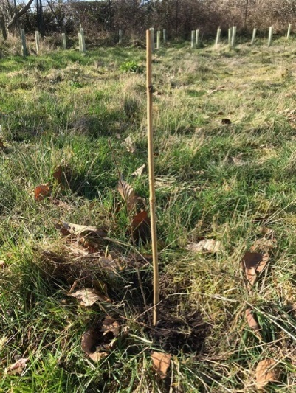
Beaumont Parish Hall received thirty hedging plants from the Woodland Trust as part of the Queen’s Green Canopy to commemorate the Queen’s Platinum Jubilee in 2022.
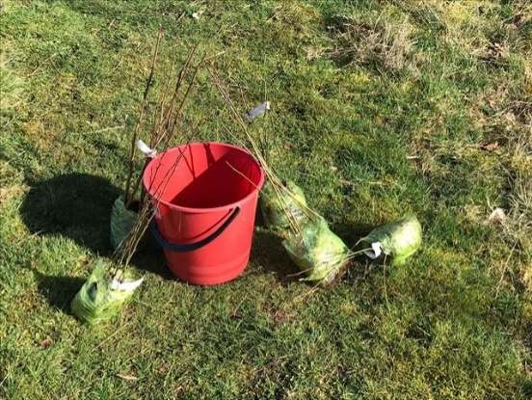
A selection of hedging plants ready for planting.
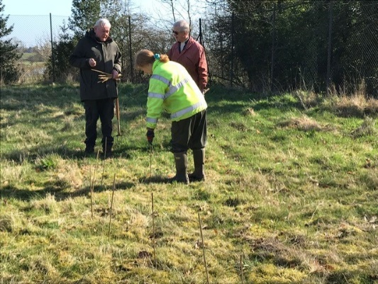
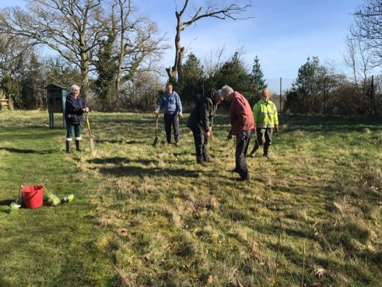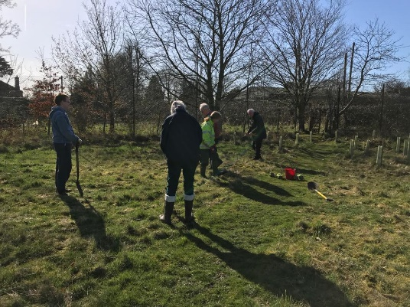
Rev. Tudor, Judith, Bryony, Malcom, Dawn and Harold plan the position of the hedging plants in the wildlife area in the grounds of Beaumont Parish Hall.
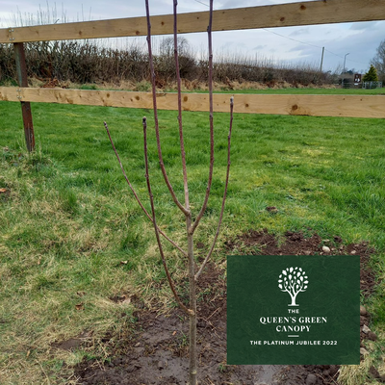
The trees have been registered with the Queen’s Green Canopy and have been awarded with a virtual Green Canopy plaque.
Click on the link to find the map showing the trees:
https://queensgreencanopy.org/map-education-hub/qgc-map/#/?id=4744

