**Beaumont Parish Hall Annual Over 60’s Tea in 2006**

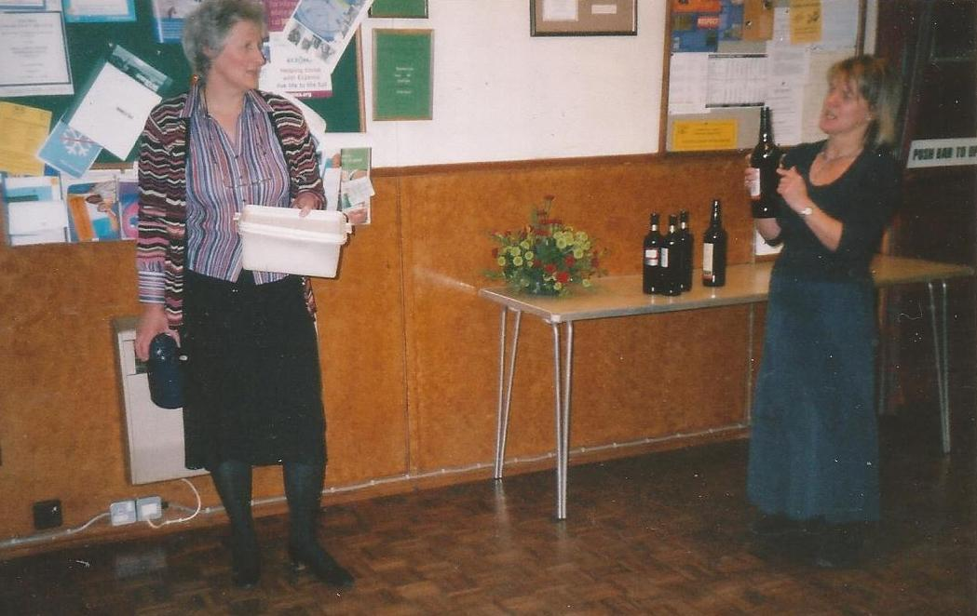

*Preparations: Margaret Harrington and Wendy Betts*

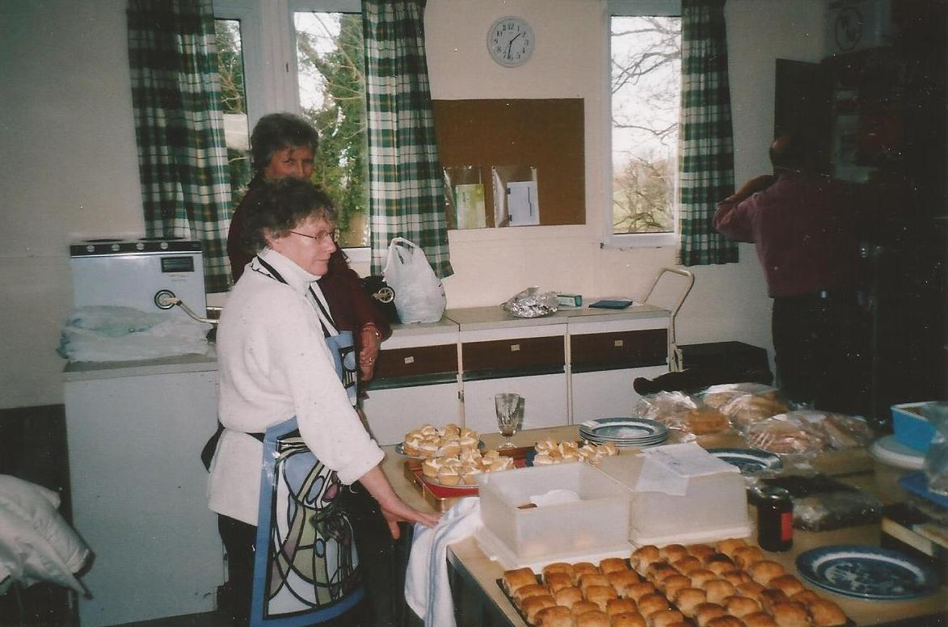

*Elsie Phillips*

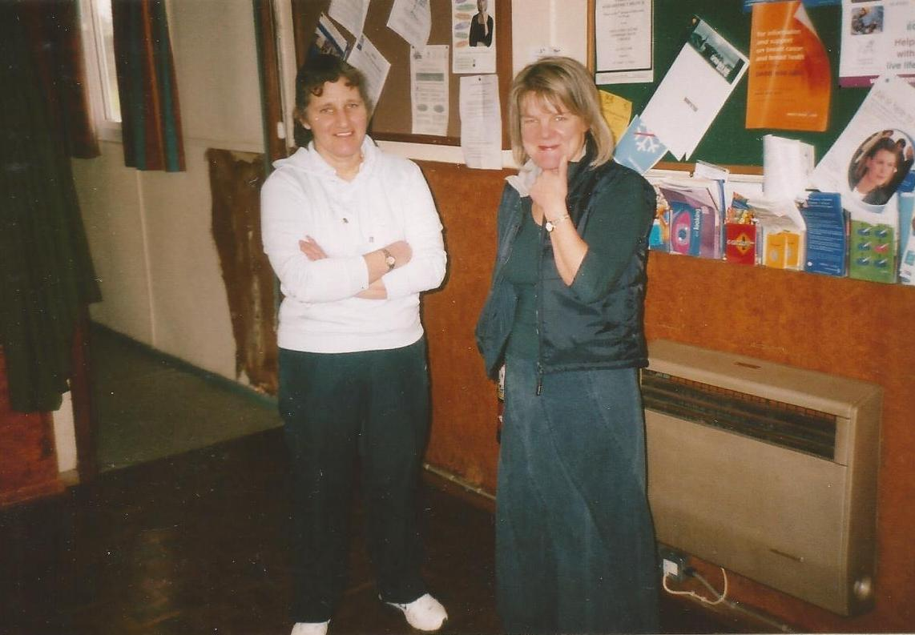

*Maryann Baxter and Wendy Betts*

