Beaumont Parish Hall Great Get Together June 2017

Photographs of the Great Get Together event held on Father’s Day in June 2017.

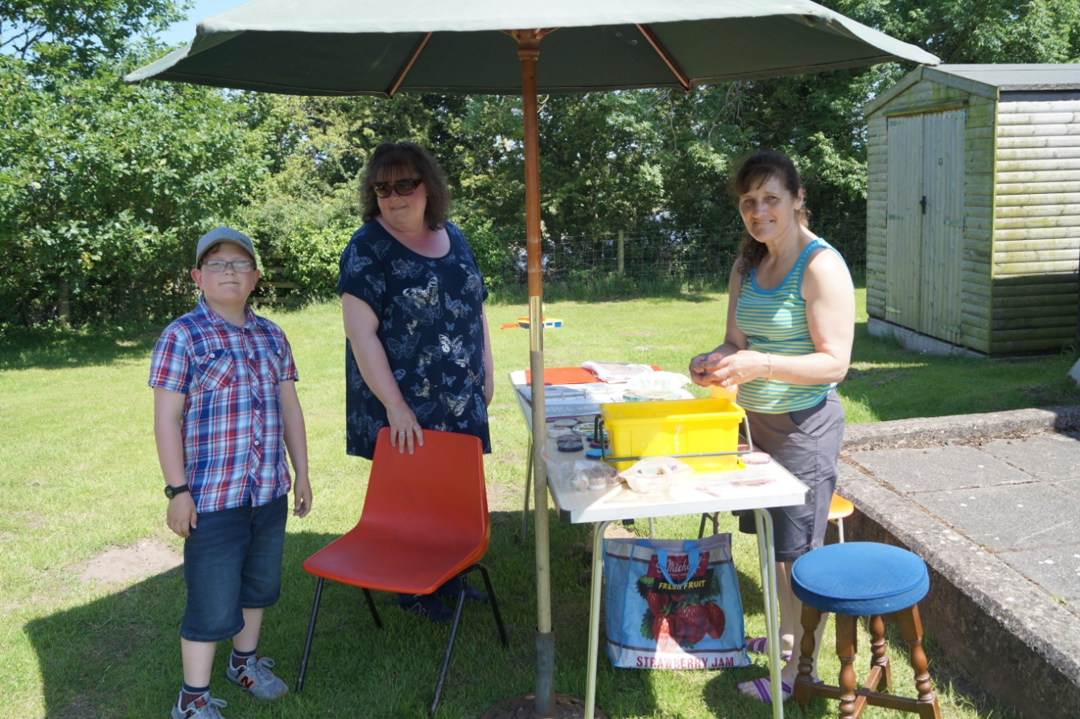
Stuart and Michelle watch MaryAnn setting up the face painting stall

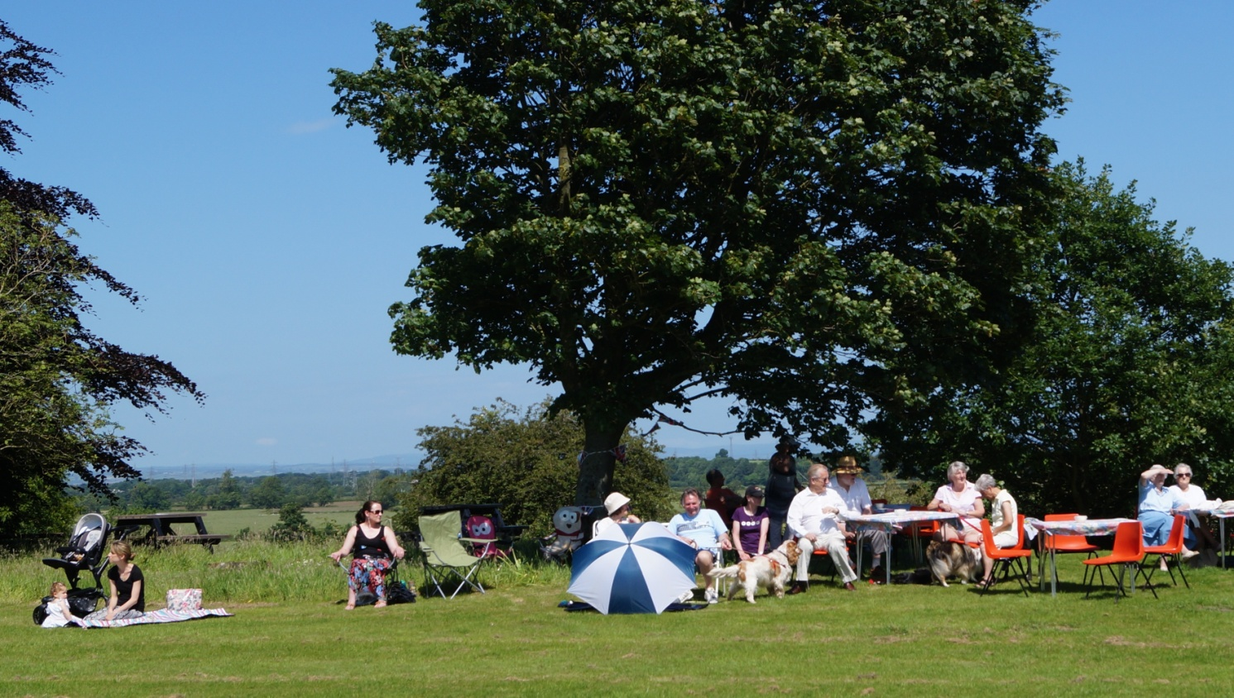
A beautiful day for the family fun followed by a bring and share afternoon tea

THE EVENTS

Children’s events
Under 7’s
Running race Winners: Ben and Lucy Peel

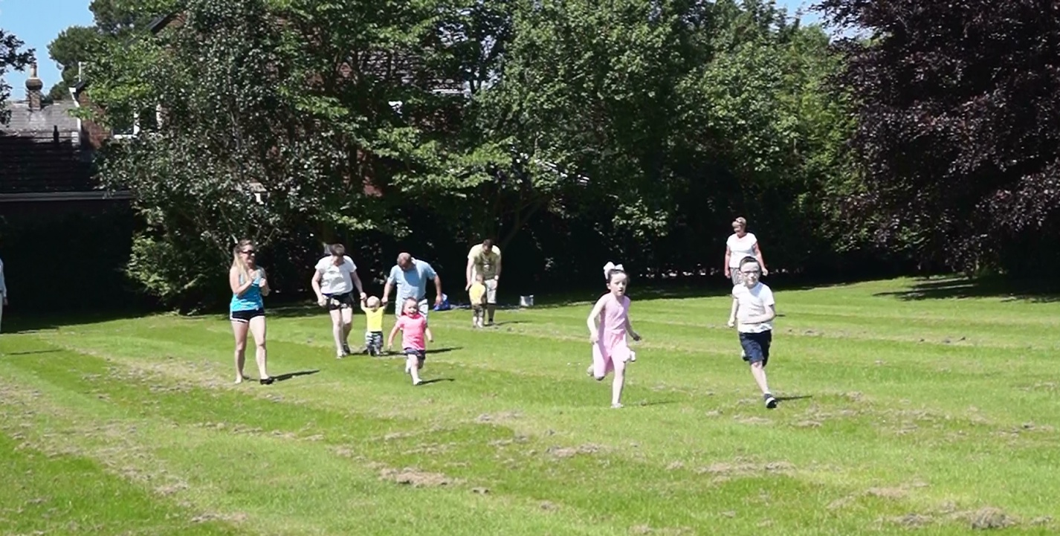
Competitors in the under 7’s running race

Welly Wanging Winner : Lucy

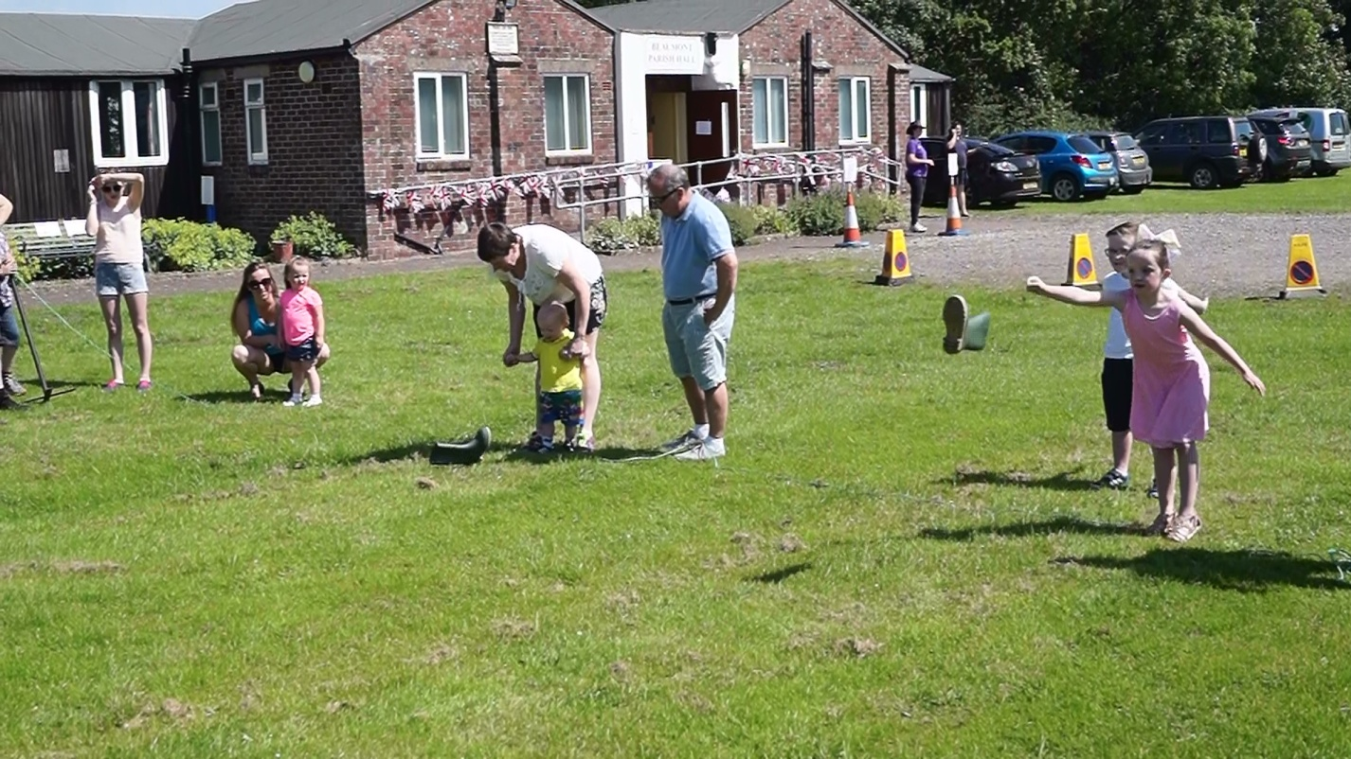

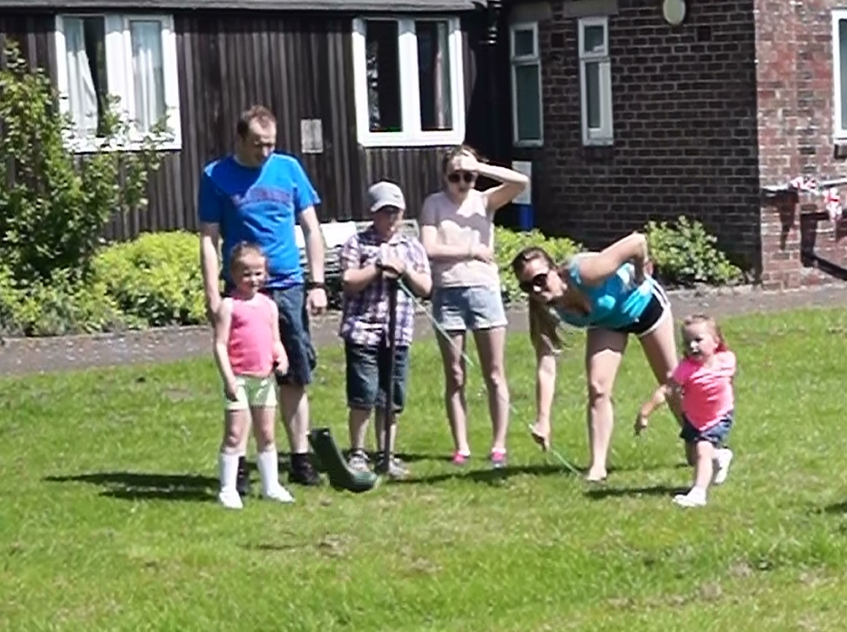

Sack race Winner: Lucy Peel

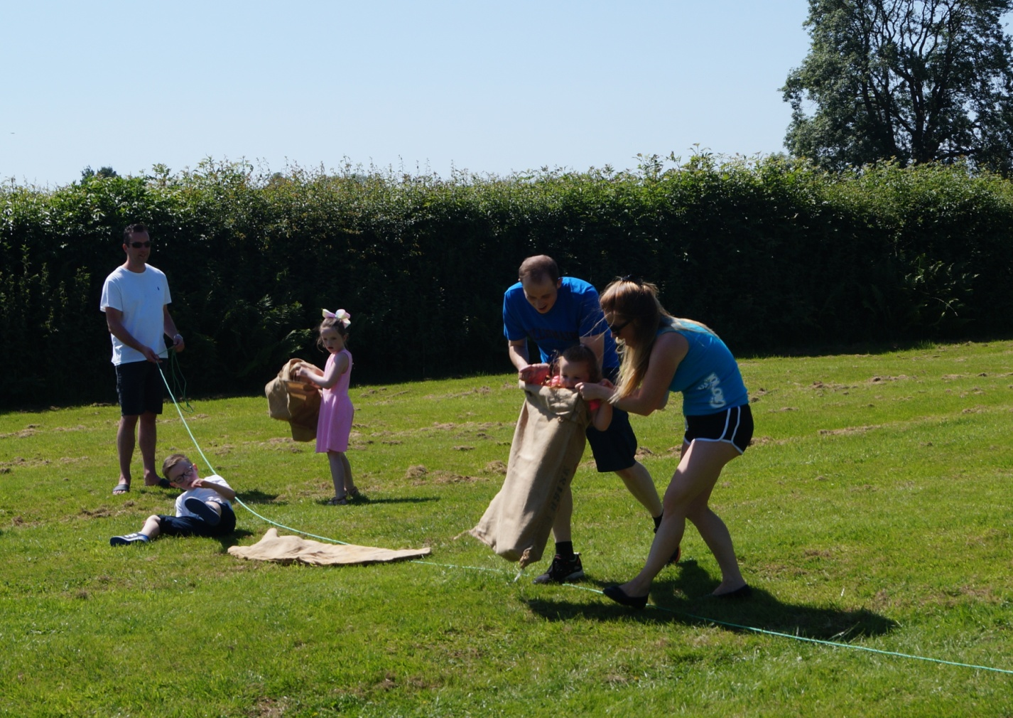
The final competitor crosses the line in the under 7’s sack race

Over 7’s

Running race 1 Winner: Katie
Running race 2 Winner: Rosie

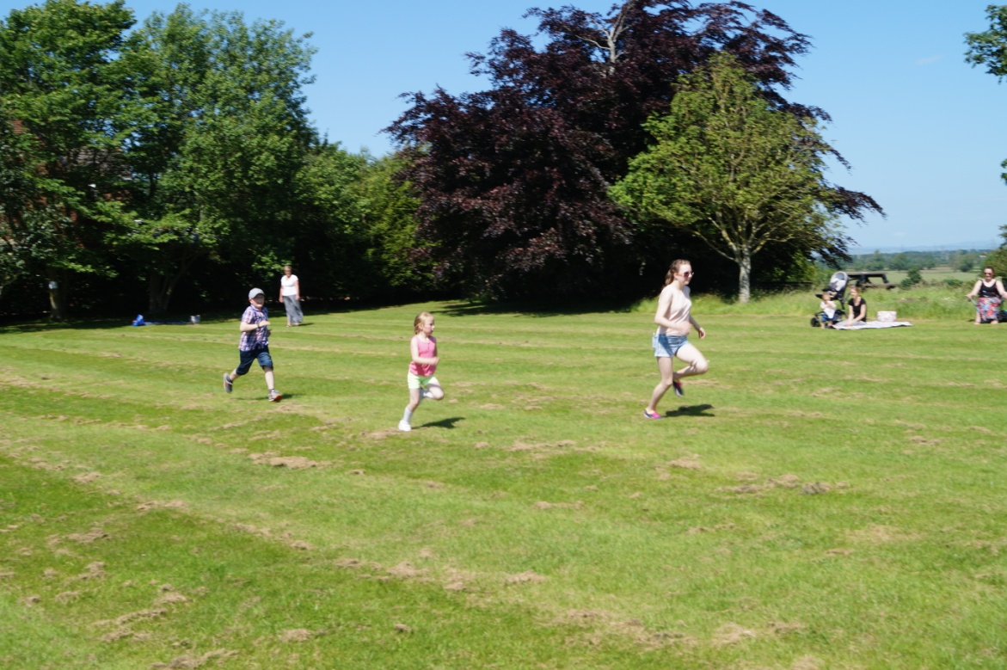

Welly Wanging Winner: Katie

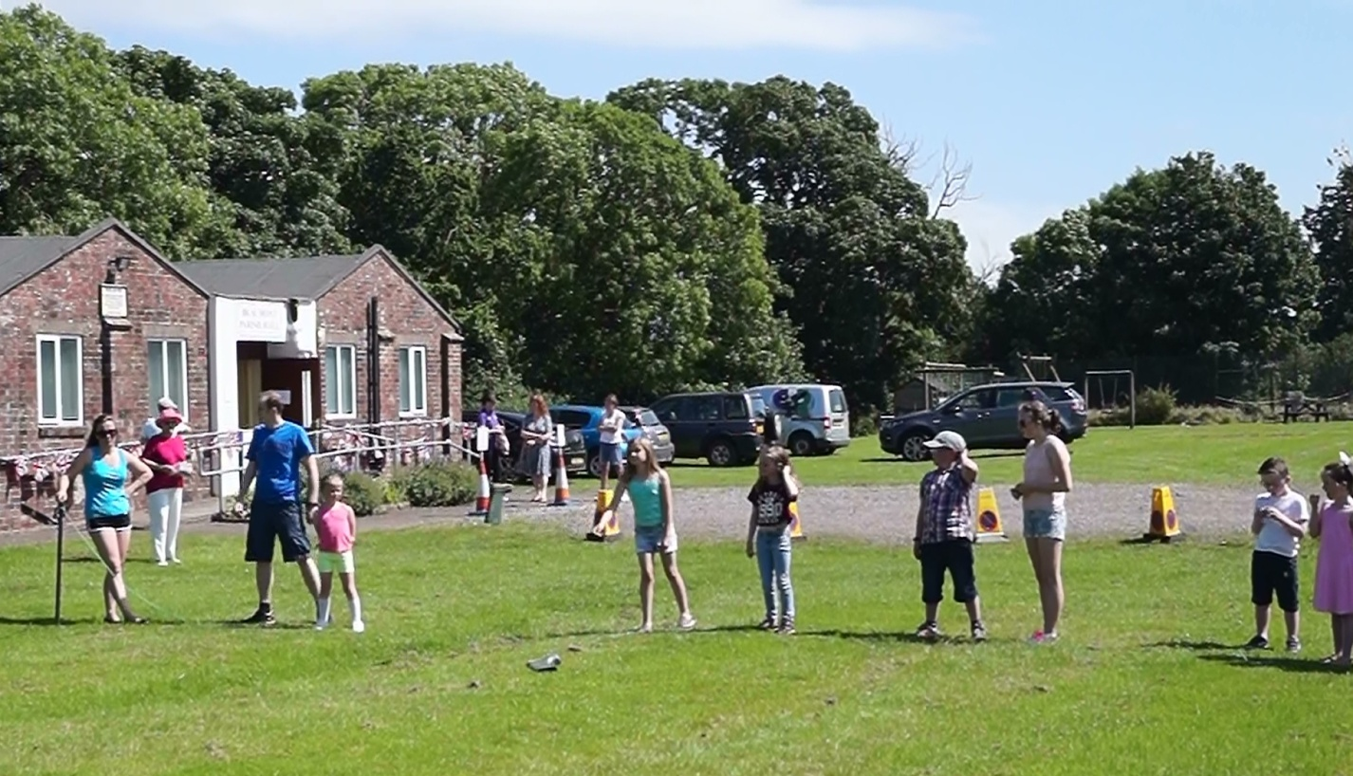

Sack race Winner: Sophie Goulston

Fancy Dress Competitions

Trevor Allison kindly judged the fancy dress competitions.

Fancy dress: “Dress like your Dad”

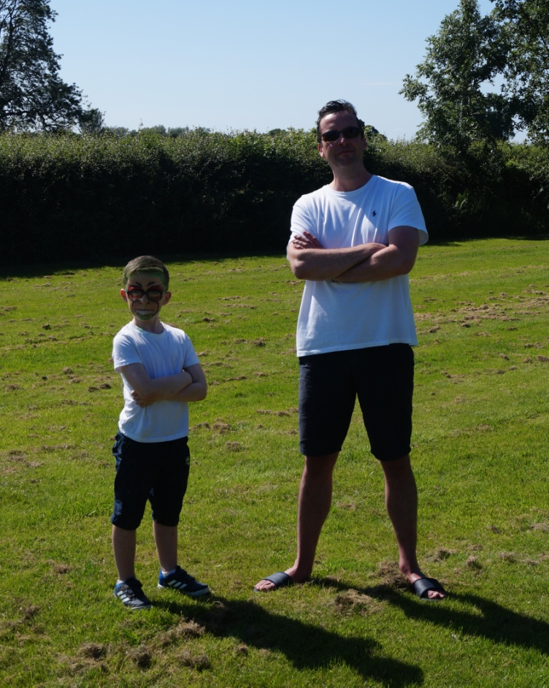
Winner of “Dress like your dad” Ben with dad, David Peel

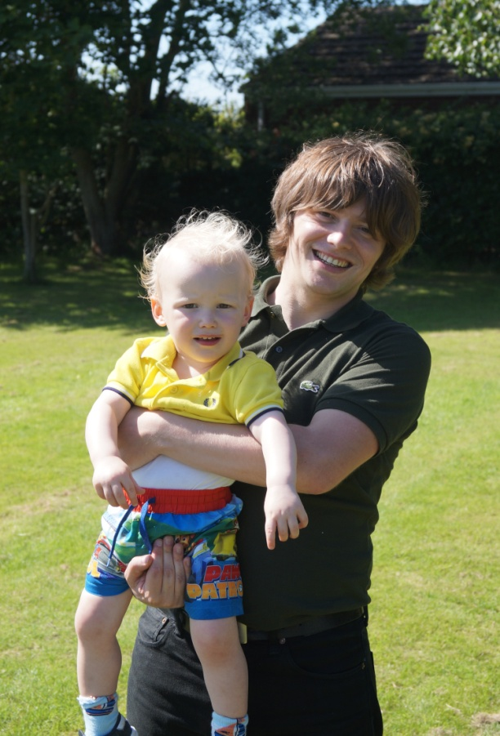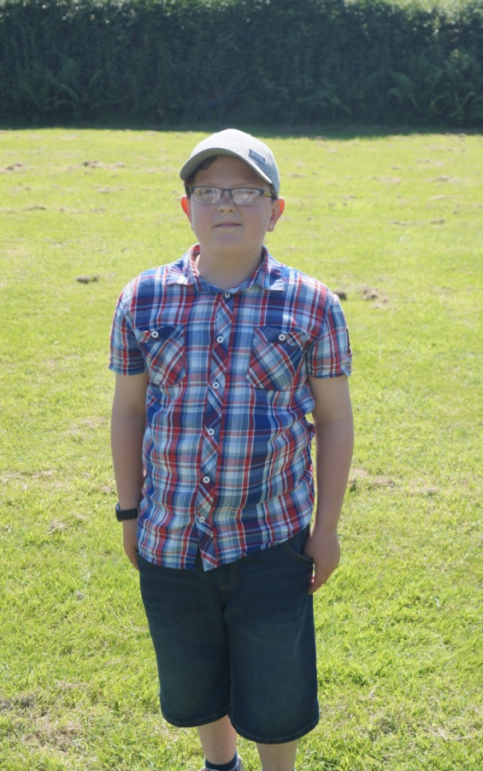
Runners up: Bobby Stuart

Fancy dress: Costume

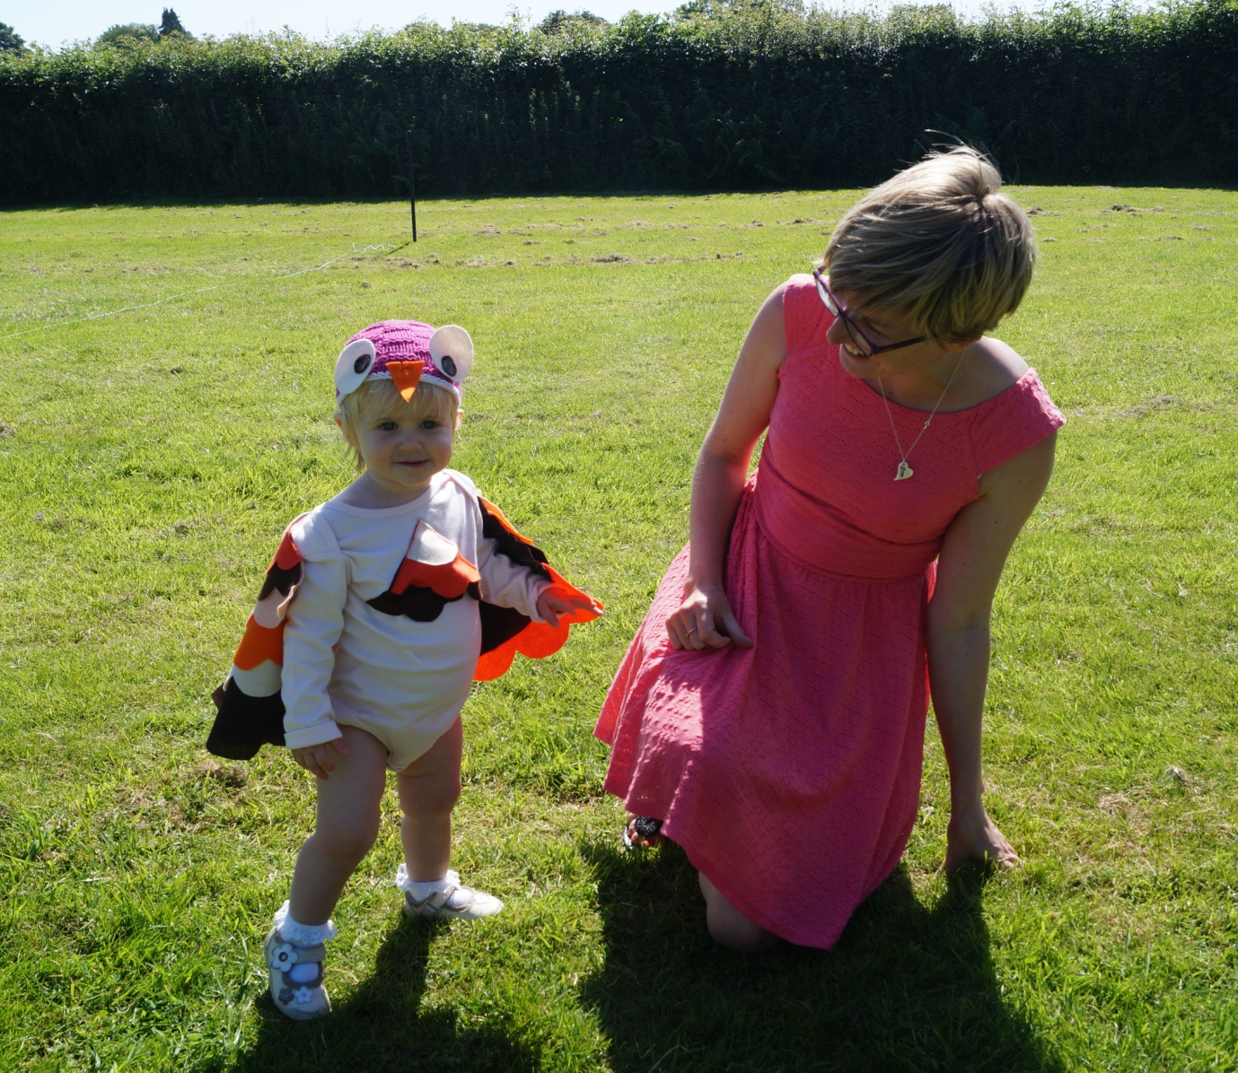
Winner Romilly Nicholson with her mother.

Adult events

Men’s events
Running Winner: James Nicholson

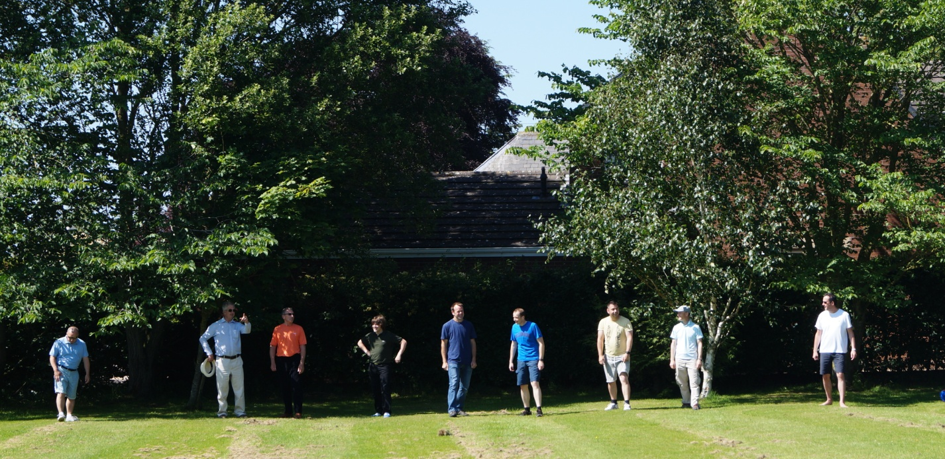
Dads running race line up.

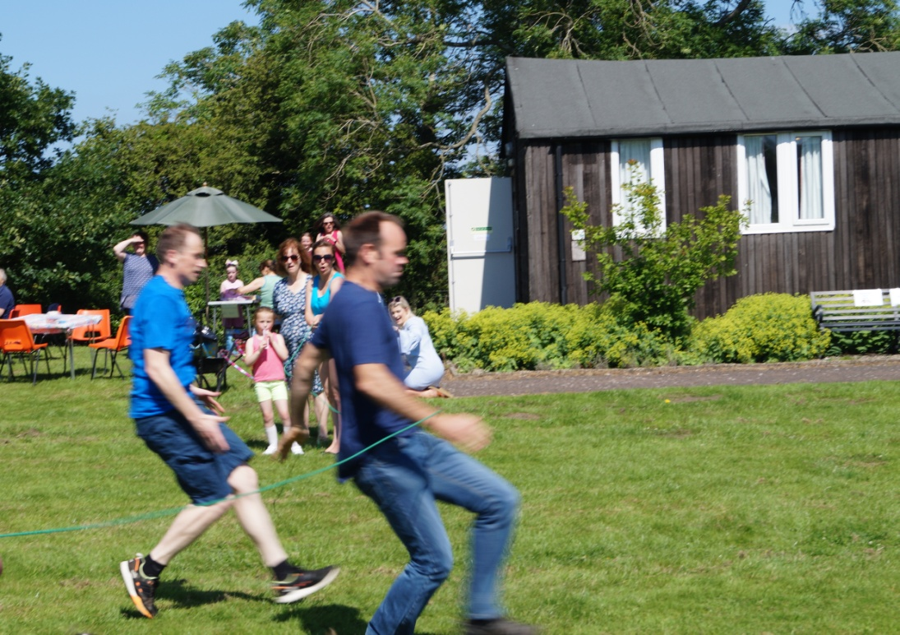
James Nicholson in the lead at the finish line

Welly wanging Winners: Chris Emmerson + David Peel

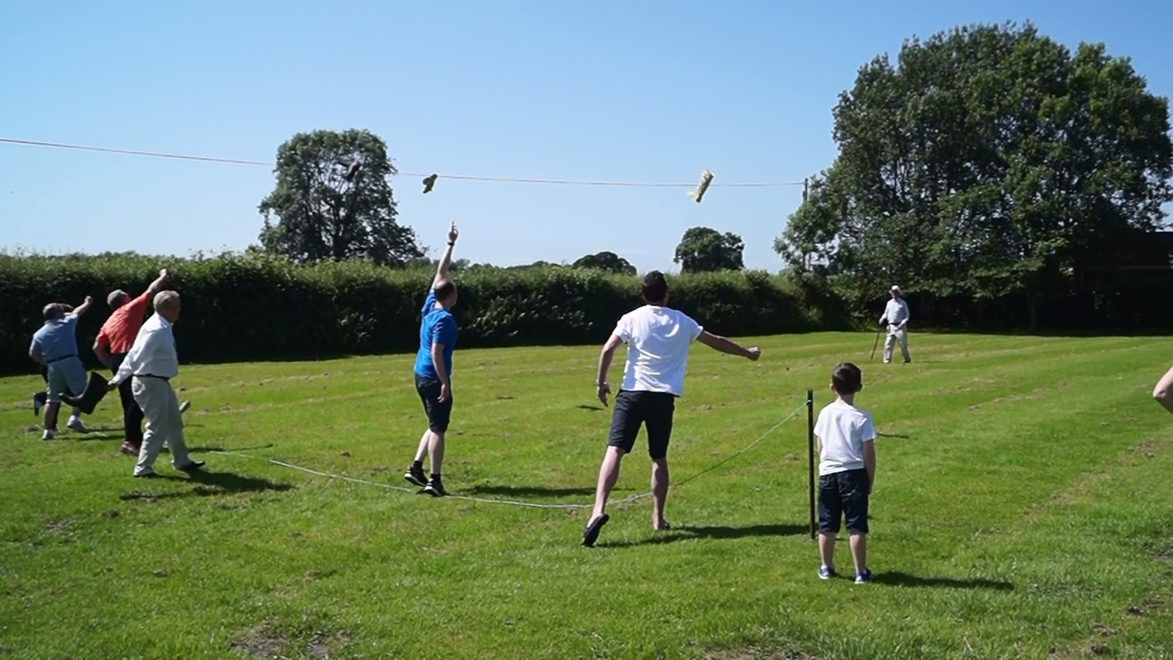

Horse shoe throwing Winner: Barry Dixon

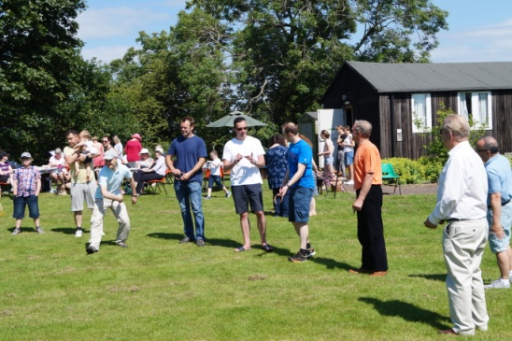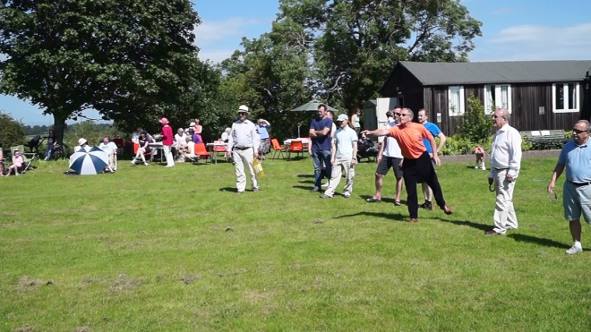

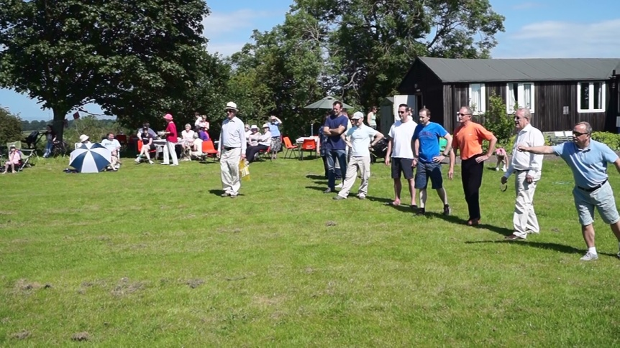
The competitors for the men’s horse shoe throwing.

Ladies’ events
Running race Winner: Jenna

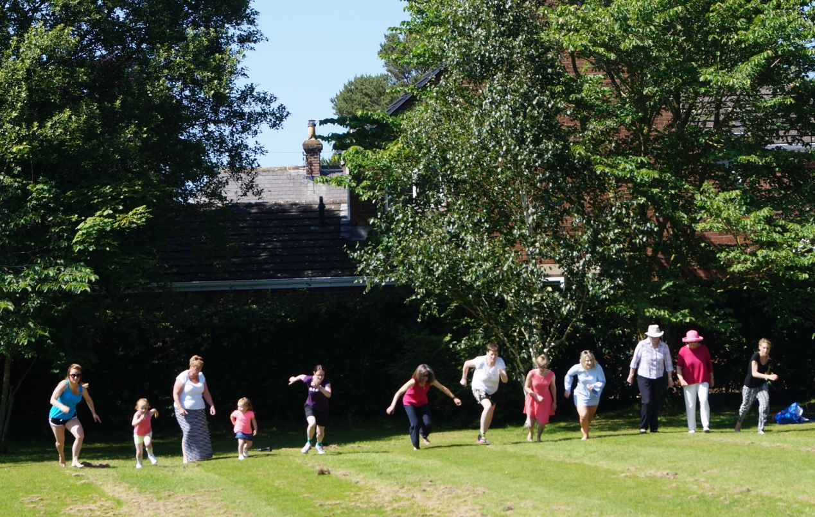
The start of the women’s running race

Welly Wanging Winners: Julie + Michelle

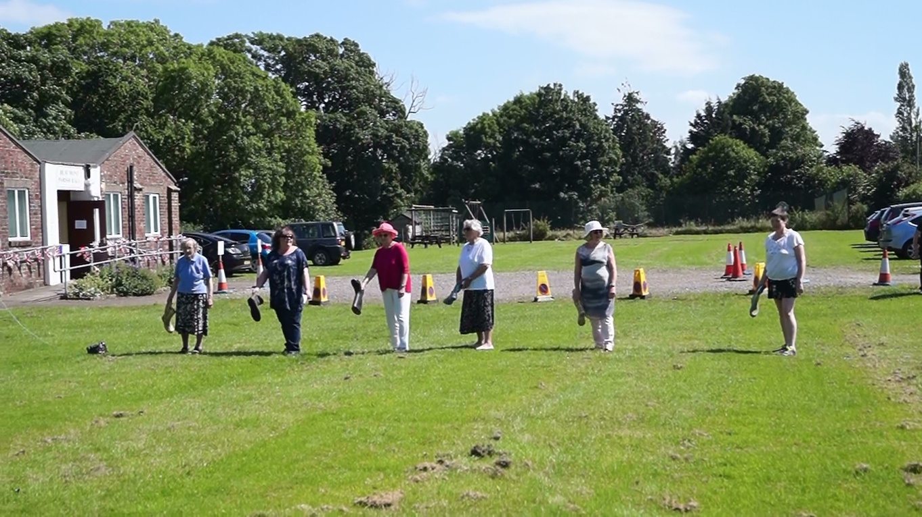
Competitors in one of the women’s welly wanging heats.

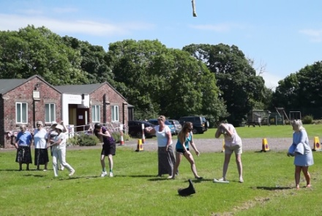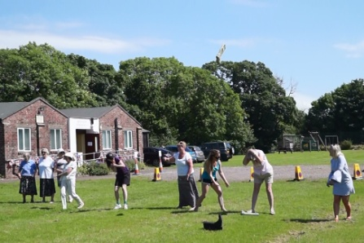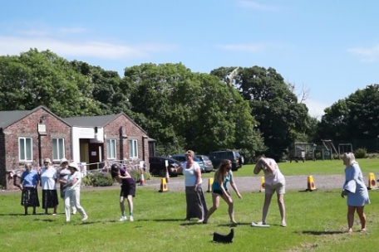

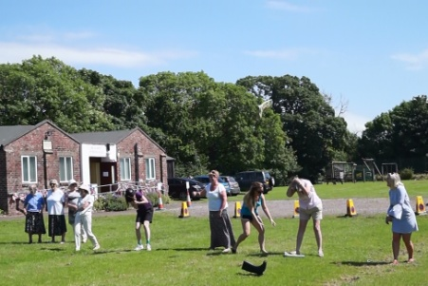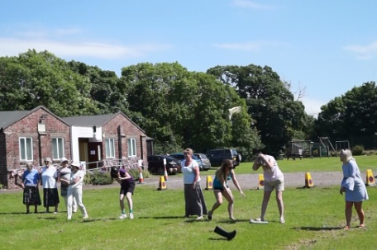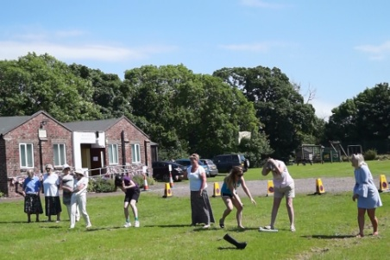
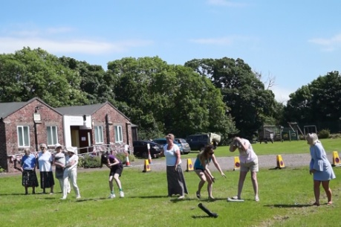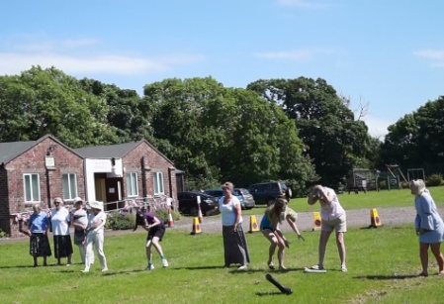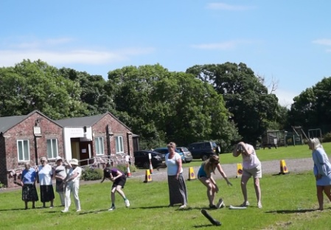
A sequence of photos showing how dangerous a welly can be, when in the wrong hands.
Notice the wellington in mid-air in the first of the sequence. Can you guess who the culprit was?

Horse shoe throwing: Charlotte Wilson

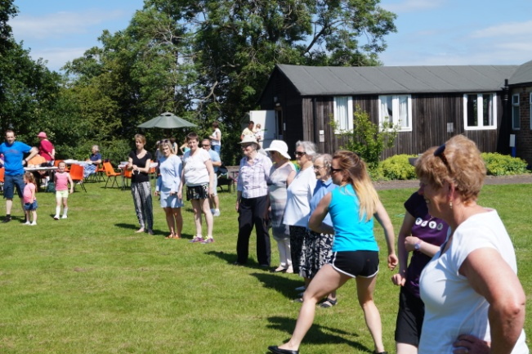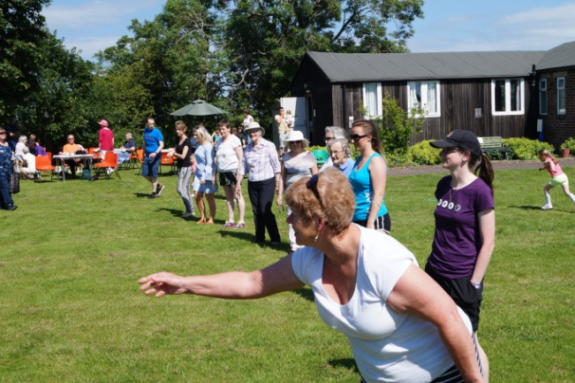

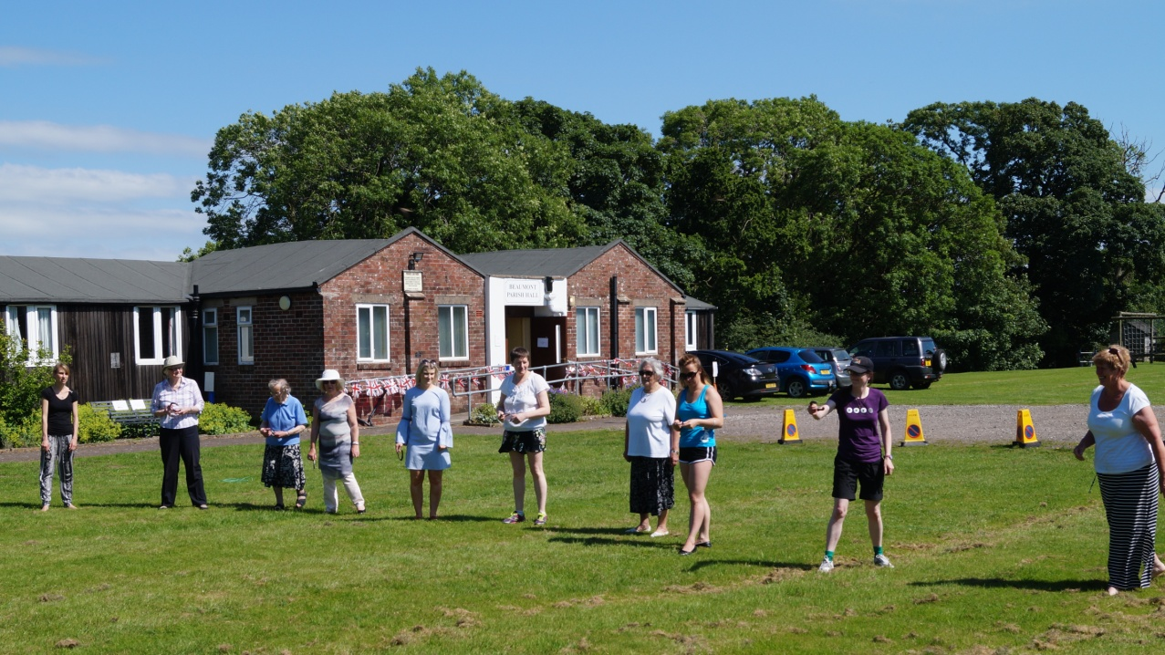
The competitors for the women’s horse shoe throwing.

A Special prize: Sadie Bell for the worst horseshoe throw.

Pet show

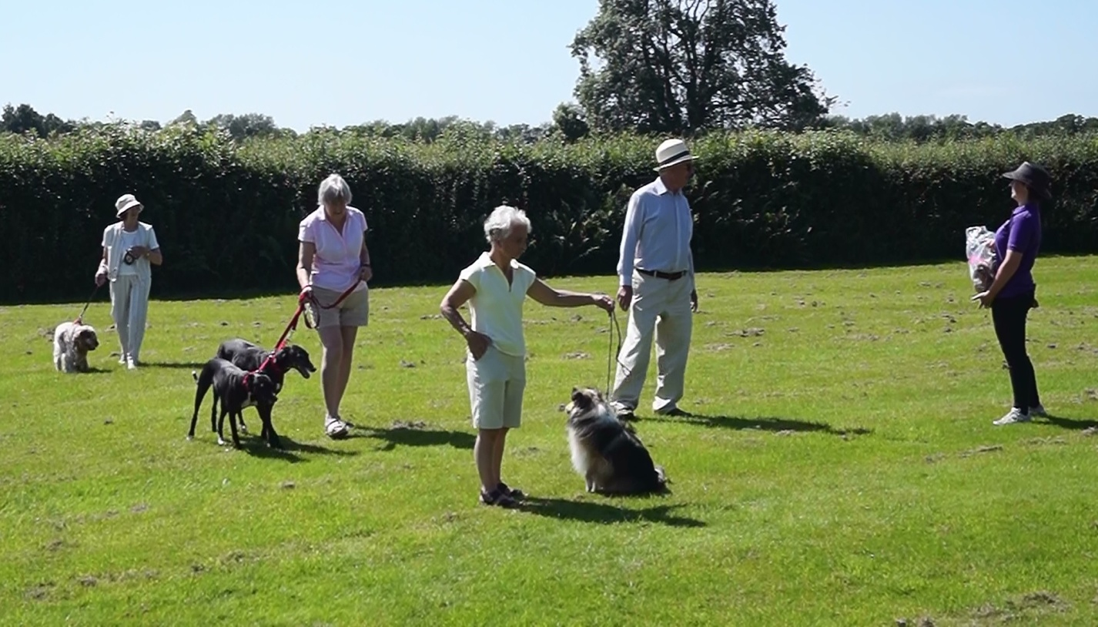Winners: Zoe with Lavinia Hughson, Dotty & Minnie with Judith Swinsco and Bertie with Lynne Graham
Elizabeth from Craig Robinson Vets kindly judged and presented the prizes.

The winners of the treasure hunt were as follows:
Stuart Dickinson, Olivia, Ben, Charlotte, Sophie Goulston and Bobby Emmerson.

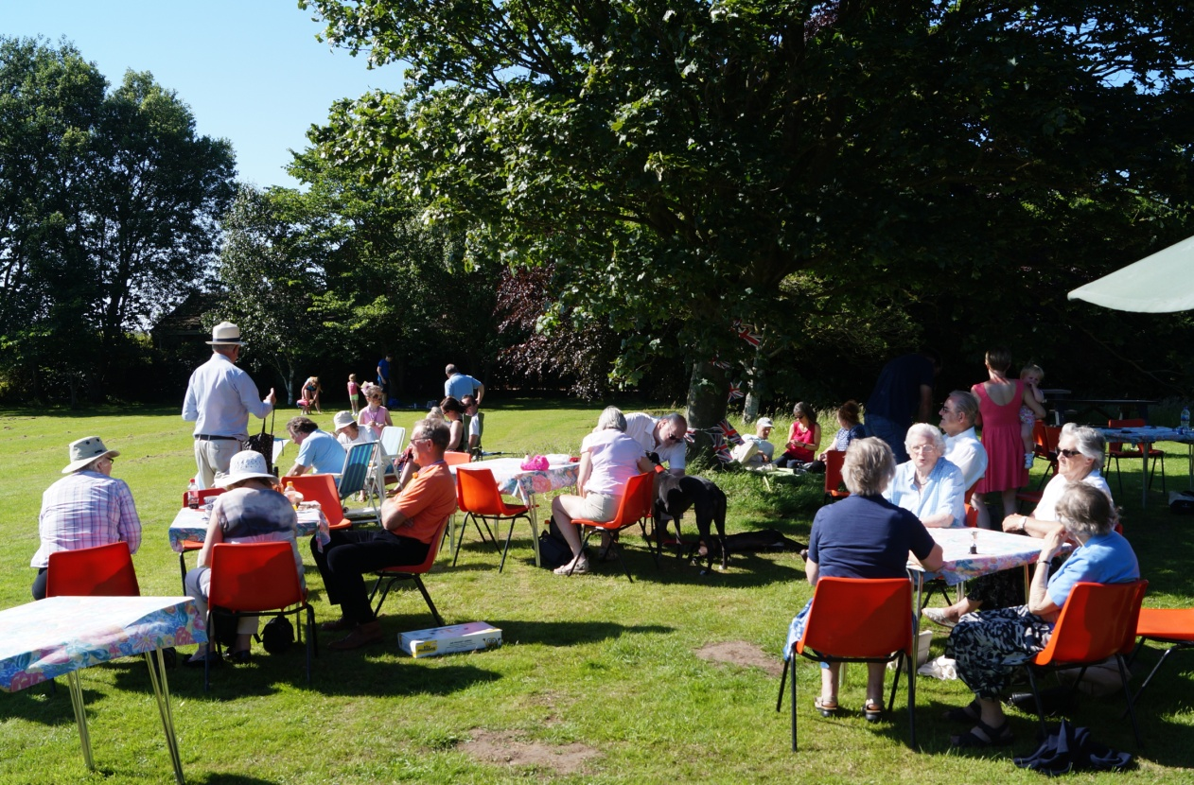
Spectating from the shade.

